1. WHAT IS THE MEANING OF FINANCE? EXPLAIN SCOPE , NATURE AND OBJECTIVES OF FINANCIAL MANAGEMENT

Business concern needs finance to meet their requirements in the economic world. Any kind of business activity depends on the finance. Hence, it is called as lifeblood of business organization. Whether the business concerns are big or small, they need finance to fulfill their business activities.

In the modern world, all the activities are concerned with the economic activities and very particular to earning profit through any venture or activities. The entire business activities are directly related with making profit. (According to the economics concept of factors of production, rent given to landlord, wage given to labour, interest given to capital and profit given to shareholders or proprietors), a business concern needs finance to meet all the requirements. Hence finance may be called as capital, investment, fund etc., but each term is having different meanings and unique characters. Increasing the profit is the main aim of any kind of economic activity.

**MEANING OF FINANCE**

Finance may be defined as the art and science of managing money. It includes financial service and financial instruments. Finance also is referred as the provision of money at the time when it is needed. Finance function is the procurement of funds and their effectiveutilization in business concerns.

The concept of finance includes capital, funds, money, and amount. But each word is having unique meaning. Studying and understanding the concept of finance become an important part of the business concern.

**DEFINITION OF FINANCE**

According to **Khan and Jain,** “Finance is the art and science of managing money”.

According to **Oxford dictionary**, the word ‘finance’ connotes ‘management of money’.

**Webster’s** Ninth New Collegiate Dictionary defines finance as “the Science on study of the management of funds’ and the management of fund as the system that includes the circulation of money, the granting of credit, the making of investments, and the provision of banking facilities.

**DEFINITION OF BUSINESS FINANCE**

According to the **Wheeler,** “Business finance is that business activity which concerns with the acquisition and conversation of capital funds in meeting financial needs and overall objectives of a business enterprise”.

**TYPES OF FINANCE**

Finance is one of the important and integral part of business concerns, hence, it plays a major role in every part of the business activities. It is used in all the area of the activities under the different names.

**Finance can be classified into two major parts:**

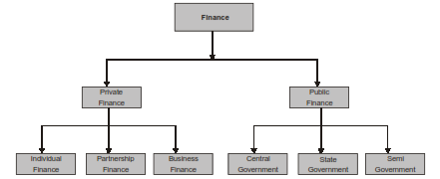

Private Finance, which includes the Individual, Firms, Business or Corporate Financial activities to meet the requirements. Public Finance which concerns with revenue and disbursement of Government such as Central Government, State Government and Semi-Government Financial matters.

**DEFINITION OF FINANCIAL MANAGEMENT**

Financial management is an integral part of overall management. It is concerned with the duties of the financial managers in the business firm. The term financial management has been defined by **Solomon**,“It is concerned with the efficient use of an important economic resource namely, capital funds”. The most popular and acceptable definition of financial management as given by **S.C.** **uchal** is that “Financial Management deals with procurement of funds and their effective utilization in the business”.

**Howard and Upton**: Financial management “as an application of general managerial

Principles to the area of financial decision-making.

**Weston and Brigham:** Financial management “is an area of financial decision-making,

harmonizing individual motives and enterprise goals”.

**Joshep and Massie**: Financial management “is the operational activity of a business

that is responsible for obtaining and effectively utilizing the funds necessary for efficient operations. Thus, Financial Management is mainly concerned with the effective funds management in the business. In simple words, Financial Management as practiced by business firms can be called as Corporation Finance or Business Finance.

**SCOPE OF FINANCIAL MANAGEMENT**

Financial management is one of the important parts of overall management, which is directly related with various functional departments like personnel, marketing and production. Financial management covers wide area with multidimensional approaches. The following are the important scope of financial management.

**1. Financial Management and Economics**

Economic concepts like micro and macroeconomics are directly applied with the financial management approaches. Investment decisions, micro and macro environmental factors are closely associated with the functions of financial manager. Financial management also uses the economic equations like money value discount factor, economic order quantity etc. Financial economics is one of the emerging area, which provides immense opportunities to finance, and economical areas.

**2. Financial Management and Accounting**

Accounting records includes the financial information of the business concern. Hence, we can easily understand the relationship between the financial management and accounting. In the olden periods, both financial management and accounting are treated as a same discipline and then it has been merged as Management Accounting because this part is very much helpful to finance manager to take decisions. But nowaday’s financial management and accounting discipline are separate and interrelated.

**3. Financial Management or Mathematics**

Modern approaches of the financial management applied large number of mathematical and statistical tools and techniques. They are also called as econometrics. Economic order quantity, discount factor, time value of money, present value of money, cost of capital, capital structure theories, dividend theories, ratio analysis and working capital analysis are used as mathematical and statistical tools and techniques in the field of financial management.

**4. Financial Management and Production Management**

Production management is the operational part of the business concern, which helps to multiple the money into profit. Profit of the concern depends upon the production performance. Production performance needs finance, because production department requires raw material, machinery, wages, operating expenses etc. These expenditures are decided and estimated by the financial department and the finance manager allocates the appropriate finance to production department. The financial manager must be aware of the operational process and finance required for each process of production activities.

**5. Financial Management and Marketing**

Produced goods are sold in the market with innovative and modern approaches. For this, the marketing department needs finance to meet their requirements. The financial manager or finance department is responsible to allocate the adequate finance to the marketing department. Hence, marketing and financial management are interrelated and depends on each other.

**. Financial Management and Human Resource**

Financial management is also related with human resource department, which provides manpower to all the functional areas of the management. Financial manager should carefully evaluate the requirement of manpower to each department and allocate the finance to the human resource department as wages, salary, remuneration, commission, bonus, pension and other monetary benefits to the human resource department. Hence, financial management is directly related with human resource management.

**OBJECTIVES OF FINANCIAL MANAGEMENT**

Effective procurement and efficient use of finance lead to proper utilization of the financey the business concern. It is the essential part of the financial manager. Hence, the financial manager must determine the basic objectives of the financial management.

**Objectives of Financial Management may be broadly divided into two parts such as:**

Profit maximization

Wealth maximization.

Wealth

Profit

Objectives

**Objectives of Financial Management**

**Profit Maximization**

Main aim of any kind of economic activity is earning profit. A business concern is also functioning mainly for the purpose of earning profit. Profit is the measuring techniques to understand the business efficiency of the concern. Profit maximization is also the traditional and narrow approach, which aims at, maximizes the profit of the concern. Profit maximization consists of the following important features. Profit maximization is also called as cashing per share maximization. It leads to maximize the business operation for profit maximization. Ultimate aim of the business concern is earning profit, hence, it considers all the possible ways to increase the profitability of the concern.

3. Profit is the parameter of measuring the efficiency of the business concern. So it shows the entire position of the business concern.

4. Profit maximization objectives help to reduce the risk of the business.

**Favourable Arguments for Profit Maximization**

The following important points are in support of the profit maximization objectives of the business concern:

(i) Main aim is earning profit.

(ii) Profit is the parameter of the business operation.

(iii) Profit reduces risk of the business concern.

(iv) Profit is the main source of finance.

(v) Profitability meets the social needs also.

**Unfavourable Arguments for Profit Maximization**

The following important points are against the objectives of profit maximization:

(i) Profit maximization leads to exploiting workers and consumers.

(ii) Profit maximization creates immoral practices such as corrupt practice, unfair trade practice, etc.

(iii) Profit maximization objectives leads to inequalities among the sake holders such as customers, suppliers, public shareholders, etc.

**Drawbacks of Profit Maximization**

Profit maximization objective consists of certain drawback also:

(i) **It is vague:** In this objective, profit is not defined precisely or correctly. It creates some unnecessary opinion regarding earning habits of the business concern.

(ii) **It ignores the time value of money:** Profit maximization does not consider the time value of money or the net present value of the cash inflow. It leads certain differences between the actual cash inflow and net present cash flow during a particular period.

(iii) **It ignores risk:** Profit maximization does not consider risk of the business

concern. Risks may be internal or external which will affect the overall operation of the business concern.

**Wealth Maximization**

Wealth maximization is one of the modern approaches, which involves latest innovations and improvements in the field of the business concern. The term wealth means shareholder wealth or the wealth of the persons those who are involved in the business concern. Wealth maximization is also known as value maximization or net present worth maximization. This objective is an universally accepted concept in the field of business.

**Favourable Arguments for Wealth Maximization**

(i) Wealth maximization is superior to the profit maximization because the main aim

of the business concern under this concept is to improve the value or wealth of the shareholders.

(ii) Wealth maximization considers the comparison of the value to cost associated with

the business concern. Total value detected from the total cost incurred for the business operation. It provides extract value of the business concern.

(iii) Wealth maximization considers both time and risk of the business concern.

(iv) Wealth maximization provides efficient allocation of resources.

(v) It ensures the economic interest of the society.

**Unfavourable Arguments for Wealth Maximization**

(i) Wealth maximization leads to prescriptive idea of the business concern but it may

not be suitable to present day business activities.

(ii) Wealth maximization is nothing, it is also profit maximization, it is the indirect name of the profit maximization.

(iii) Wealth maximization creates ownership-management controversy.

(iv) Management alone enjoy certain benefits.

(v) The ultimate aim of the wealth maximization objectives is to maximize the profit.

(vi) Wealth maximization can be activated only with the help of the profitable position

of the business concern.

**2.WHAT ARE FUNCTIONS OF FINANCIAL MANAGER?**

Finance function is one of the major parts of business organization, which involves the permanent, and continuous process of the business concern. Finance is one of the interrelated functions which deal with personal function, marketing function, production function and research and development activities of the business concern. At present, every business concern concentrates more on the field of finance because, it is a very emerging part which reflects the entire operational and profit ability position of the concern. Deciding the proper financial function is the essential and ultimate goal of the business organization. Finance manager is one of the important role players in the field of finance function. He must have entire knowledge in the area of accounting, finance, economics and management. His position is highly critical and analytical to solve various problems related to finance. A person who deals finance related activities may be called finance manager.

**Finance manager performs the following major functions:**

**1. Forecasting Financial Requirements**

It is the primary function of the Finance Manager. He is responsible to estimate the financial requirement of the business concern. He should estimate, how much finances required to acquire fixed assets and forecast the amount needed to meet the working capital requirements in future.

**2. Acquiring Necessary Capital**

After deciding the financial requirement, the finance manager should concentrate how the finance is mobilized and where it will be available. It is also highly critical in nature.

**3. Investment Decision**

The finance manager must carefully select best investment alternatives and consider

the reasonable and stable return from the investment. He must be well versed in the field of capital budgeting techniques to determine the effective utilization of investment. The finance manager must concentrate to principles of safety, liquidity and profitability while investing capital.

**4. Cash Management**

Present days cash management plays a major role in the area of finance because proper cash management is not only essential for effective utilization of cash but it also helps to meet the short-term liquidity position of the concern.

**5. Interrelation with Other Departments**

Finance manager deals with various functional departments such as marketing, production, personel, system, research, development, etc. Finance manager should have sound knowledge not only in finance related area but also well versed in other areas. He must maintain a good relationship with all the functional departments of the business organization.

**FUNDS FLOW STATEMENT**

Funds flow statement is one of the important tools, which is used in many ways. It helps to understand the changes in the financial position of a business enterprise between the beginning and ending financial statement dates. It is also called as statement of sources and uses of funds.

Institute of Cost and Works Accounts of India, funds flow statement is defined as “a

statement prospective or retrospective, setting out the sources and application of the funds of an enterprise. The purpose of the statement is to indicate clearly the requirement of funds and how they are proposed to be raised and the efficient utilization and application of the same”. Financial Statement Analysis

**3. EXPLAIN CASH FLOW STATEMENTAND FUNDS FLOW STATEMENT?**

1. **.CASH FLOW STATEMENT**

Cash flow statement is a statement which shows the sources of cash inflow and uses of cash out-flow of the business concern during a particular period of time. It is the statement, which involves only short-term financial position of the business concern. Cash flow statement provides a summary of operating, investment and financing cash flows and reconciles them with changes in its cash and cash equivalents such as marketable securities. Institute of Chartered Accountants of India issued the Accounting Standard (AS-3) related to the preparation of cash flow statement in 1998.

**B). FUNDS FLOW STATEMENT**

Funds flow statement is one of the important tools, which is used in many ways. It helps to understand the changes in the financial position of a business enterprise between the beginning and ending financial statement dates. It is also called as statement of sources and uses of funds.

Institute of Cost and Works Accounts of India, funds flow statement is defined as “a

statement prospective or retrospective, setting out the sources and application of the funds of an enterprise. The purpose of the statement is to indicate clearly the requirement of funds and how they are proposed to be raised and the efficient utilization and application of the same”. Financial Statement Analysis

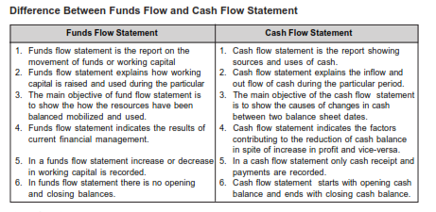

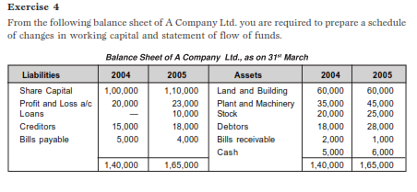

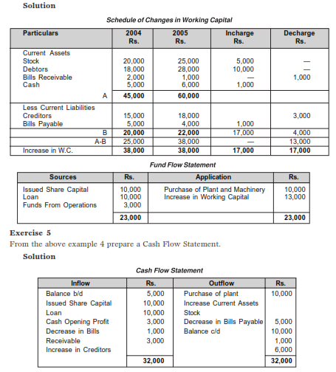

**4.DESCRIBE ABOUT CLASSIFICATION OF RATIO ANALYSIS?**

Ratio analysis is a commonly used tool of financial statement analysis. Ratio is a mathematical relationship between one number to another number. Ratio is used as an index for evaluating the financial performance of the business concern. An accounting ratio shows the mathematical relationship between two figures, which have meaningful relation with each other. Ratio can be classified into various types.

Classification from the point of view of financial management is as follows:

● Liquidity Ratio

● Activity Ratio

● Solvency Ratio

● Profitability Ratio

**Liquidity Ratio**

It is also called as short-term ratio. This ratio helps to understand the liquidity in a business which is the potential ability to meet current obligations. This ratio expresses the relationship between current assets and current assets of the business concern during a particular period. The following are the major liquidity ratio:

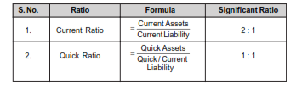

**Activity Ratio**

It is also called as turnover ratio. This ratio measures the efficiency of the current assets and liabilities in the business concern during a particular period. This ratio is helpful to understand the performance of the business concern. Some of the activity ratios are given below:

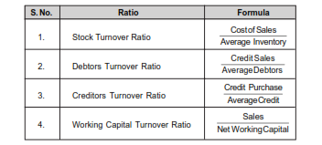

**Solvency Ratio**

It is also called as leverage ratio, which measures the long-term obligation of the business concern. This ratio helps to understand, how the long-term funds are used in the business concern. Some of the solvency ratios are given below:

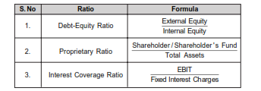

**Profitability Ratio**

Profitability ratio helps to measure the profitability position of the business concern. Some of the major profitability ratios are given below.

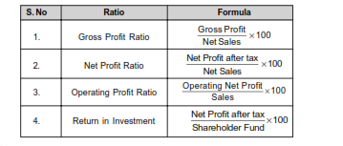

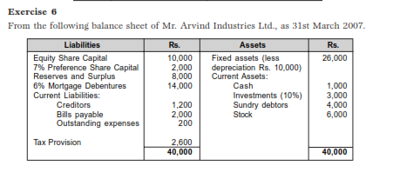

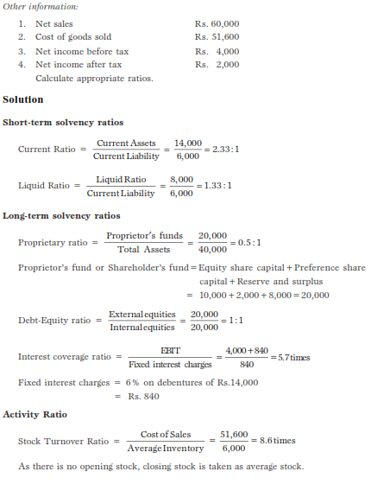

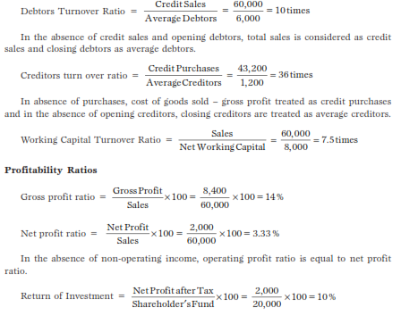

**5. WHAT IS THE MEANING OF CAPITAL? EXPLAIN TYPES OF CAPITAL?**

Financial planning and decision play a major role in the field of financial management which consists of the major area of financial management such as, capitalization, financial structure, capital structure, leverage and financial forecasting.

**Financial planning includes the following important parts**:

● Estimating the amount of capital to be raised.

● Determining the form and proportionate amount of securities.

● Formulating policies to manage the financial plan.

**MEANING OF CAPITAL**

The term capital refers to the total investment of the company in terms of money, and

assets. It is also called as total wealth of the company. When the company is going to invest large amount of finance into the business, it is called as capital. Capital is the initial and integral part of new and existing business concern.

The capital requirements of the business concern may be classified into two categories:

(a) Fixed capital

(b) Working capital.

**Fixed Capital**

Fixed capital is the capital, which is needed for meeting the permanent or long-term purpose of the business concern. Fixed capital is required mainly for the purpose of meeting capital expenditure of the business concern and it is used over a long period. It is the amount invested in various fixed or permanent assets, which are necessary for a business concern.

**Definition of Fixed Capital**

According to the definition of **Hoagland,** “Fixed capital is comparatively easily defined to include land, building, machinery and other assets having a relatively permanent existence”.

**Character of Fixed Capital**

● Fixed capital is used to acquire the fixed assets of the business concern.

● Fixed capital meets the capital expenditure of the business concern.

● Fixed capital normally consists of long period.

● Fixed capital expenditure is of nonrecurring nature.

● Fixed capital can be raised only with the help of long-term sources of finance.

**Working Capital**

Working capital is the capital which is needed to meet the day-to-day transaction of the business concern. It may cross working capital and net working capital. Normally working capital consists of various compositions of current assets such as inventories, bills, receivable, debtors, cash, and bank balance and prepaid expenses.

According to the definition of **Bonneville,** “any acquisition of funds which increases

the current assets increase the Working Capital also for they are one and the same”.

Working capital is needed to meet the following purpose:

● Purchase of raw material

● Payment of wages to workers

● Payment of day-to-day expenses

● Maintenance expenditure etc.

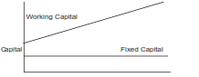

**CAPITALIZATION**

Capitalization is one of the most important parts of financial decision, which is related to the total amount of capital employed in the business concern.

Understanding the concept of capitalization leads to solve many problems in the field of financial management. Because there is a confusion among the capital, capitalization and capital structure.

**Meaning of Capitalization**

Capitalization refers to the process of determining the quantum of funds that a firm needs to run its business. Capitalization is only the par value of share capital and debenture and it does not include reserve and surplus.

**TYPES OF CAPITALIZATION**

Capitalization may be classified into the following three important types based on its nature:

• Over Capitalization

• Under Capitalization

• Water Capitalization

**Over Capitalization**

Over capitalization refers to the company which possesses an excess of capital in relation to its activity level and requirements. In simple means, over capitalization is more capital than actually required and the funds are not properly used.

According to **Bonneville, Dewey and Kelly,** over capitalization means, “when a

business is unable to earn fair rate on its outstanding securities”.

***Example***

A company is earning a sum of Rs. 50,000 and the rate of return expected is 10%. This company will be said to be properly capitalized. Suppose the capital investment of the company is Rs. 60,000, it will be over capitalization to the extent of Rs. 1,00,000.

The new rate of earning would be: 50,000/60,000×100=8.33%

When the company has over capitalization, the rate of earnings will be reduced from

10% to 8.33%.

**Causes of Over Capitalization**

Over capitalization arise due to the following important causes:

• Over issue of capital by the company.

• Borrowing large amount of capital at a higher rate of interest.

• Providing inadequate depreciation to the fixed assets.

• Excessive payment for acquisition of goodwill.

• High rate of taxation.

• Under estimation of capitalization rate.

**Effects of Over Capitalization**

Over capitalization leads to the following important effects:

• Reduce the rate of earning capacity of the shares.

• Difficulties in obtaining necessary capital to the business concern.

• It leads to fall in the market price of the shares.

• It creates problems on re-organization.

• It leads under or misutilisation of available resources.

**Remedies for Over Capitalization**

Over capitalization can be reduced with the help of effective management and systematic design of the capital structure. The following are the major steps to reduce over capitalization.

• Efficient management can reduce over capitalization.

• Redemption of preference share capital which consists of high rate of dividend.

• Reorganization of equity share capital.

• Reduction of debt capital.

**Under Capitalization**

Under capitalization is the opposite concept of over capitalization and it will occur when the company’s actual capitalization is lower than the capitalization as warranted by its earning capacity. Under capitalization is not the so called inadequate capital. Under capitalization can be defined by **Gerstenberg,** “a corporation may be under capitalized when the rate of profit is exceptionally high in the same industry”.

**Hoagland** defined under capitalization as “an excess of true assets value oaggregate of stocks and bonds outstanding”.

**Causes of Under Capitalization**

Under capitalization arises due to the following important causes:

• Under estimation of capital requirements.

• Under estimation of initial and future earnings.

• Maintaining high standards of efficiency.

• Conservative dividend policy.

• Desire of control and trading on equity.

**Effects of Under Capitalization**

Under Capitalization leads certain effects in the company and its shareholders.

• It leads to manipulate the market value of shares.

• It increases the marketability of the shares.

• It may lead to more government control and higher taxation.

• Consumers feel that they are exploited by the company.

• It leads to high competition.

**Remedies of Under Capitalization**

Under Capitalization may be corrected by taking the following remedial measures:

1. Under capitalization can be compensated with the help of fresh issue of shares.

2. Increasing the par value of share may help to reduce under capitalization.

3. Under capitalization may be corrected by the issue of bonus shares to the existing shareholders.

4. Reducing the dividend per share by way of splitting up of shares.

**altered Capitalization**

If the stock or capital of the company is not mentioned by assets of equivalent v

called as watered stock. In simple words, watered capital means that the realizable value of assets of the company is less than its book value.

According to **Hoagland’s** definition, “A stock is said to be watered when its true value

is less than its book value.”

**Causes of Watered Capital**

Generally watered capital arises at the time of incorporation of a company but it also arises during the life time of the business.

The following are the main causes of watered capital:

1. Acquiring the assets of the company at high price.

2. Adopting ineffective depreciation policy.

3. Worthless intangible assets are purchased at higher price.

**6.EXPLAIN THE CAPITAL STRUCTURE ?**

Capital is the major part of all kinds of business activities, which are decided by the size, and nature of the business concern. Capital may be raised with the help of various sources. If the company maintains proper and adequate level of capital, it will earn high profit and they can provide more dividends to its shareholders.

**Meaning of Capital Structure**

Capital structure refers to the kinds of securities and the proportionate amounts that make up capitalization. It is the mix of different sources of long-term sources such as equity shares, preference shares, debentures, long-term loans and retained earnings.

The term capital structure refers to the relationship between the various long-term source financing such as equity capital, preference share capital and debt capital. Deciding the suitable capital structure is the important decision of the financial management because it is closely related to the value of the firm. Capital structure is the permanent financing of the company represented primarily by long-term debt and equity.

**Definition of Capital Structure**

The following definitions clearly initiate, the meaning and objective of the capital structures.

According to the definition of **Gerestenbeg,**  “Capital Structure of a company refers

to the composition or make up of its capitalization and it includes all long-term capital

resources”.

According to the definition of **James C. Van Horne,** “The mix of a firm’s permanent

long-term financing represented by debt, preferred stock, and common stock equity”.

According to the definition of **Presana Chandra,** “The composition of a firm’s

financing consists of equity, preference, and debt”.

According to the definition of **R.H. Wessel,** “The long term sources of fund employed

in a business enterprise”.

**FINANCIAL STRUCTURE**

The term financial structure is different from the capital structure. Financial structure

shows the pattern total financing. It measures the extent to which total funds are available

to finance the total assets of the business.

Financial Structure = Total liabilities

Or

Financial Structure = Capital Structure + Current liabilities.

The following points indicate the difference between the financial structure and capital

structure.

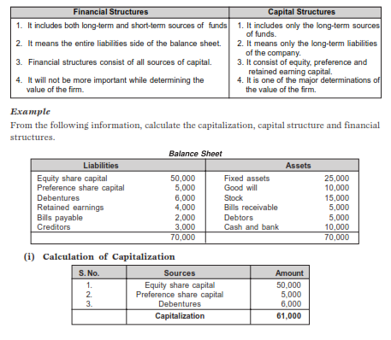

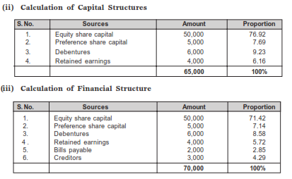

**OPTIMUM CAPITAL STRUCTURE**

Optimum capital structure is the capital structure at which the weighted average cost of

capital is minimum and thereby the value of the firm is maximum.

Optimum capital structure may be defined as the capital structure or combination of

debt and equity, that leads to the maximum value of the firm.

**Objectives of Capital Structure**

Decision of capital structure aims at the following two important objectives:

1. Maximize the value of the firm.

2. Minimize the overall cost of capital.

**Forms of Capital Structure**

Capital structure pattern varies from company to company and the availability of finance.

Normally the following forms of capital structure are popular in practice.

• Equity shares only.

• Equity and preference shares only.

• Equity and Debentures only.

• Equity shares, preference shares and debentures.

**FACTORS DETERMINING CAPITAL STRUCTURE**

The following factors are considered while deciding the capital structure of the firm.

**Leverage**

It is the basic and important factor, which affect the capital structure. It uses the fixed cost financing such as debt, equity and preference share capital. It is closely related to the overall cost of capital.

**7.Cost of Capital**

Cost of capital constitutes the major part for deciding the capital structure of a firm.

Normally long- term finance such as equity and debt consist of fixed cost while mobilization.

When the cost of capital increases, value of the firm will also decrease. Hence the firm

must take careful steps to reduce the cost of capital.

**(a) Nature of the business:** Use of fixed interest/dividend bearing finance depends

upon the nature of the business. If the business consists of long period of operation, it will apply for equity than debt, and it will reduce the cost of capital.

**(b) Size of the company:** It also affects the capital structure of a firm. If the firm belongs to large scale, it can manage the financial requirements with the help of internal sources. But if it is small size, they will go for external finance. It consists of high cost of capital.

**(c) Legal requirements:** Legal requirements are also one of the considerations while

dividing the capital structure of a firm. For example, banking companies are

restricted to raise funds from some sources.

**(d) Requirement of investors:** In order to collect funds from different type of investors, it will be appropriate for the companies to issue different sources of securities.

**Government policy**

Promoter contribution is fixed by the company Act. It restricts to mobilize large, long- term funds from external sources. Hence the company must consider government policy regarding the capital structure.

**CAPITAL STRUCTURE THEORIES**

Capital structure is the major part of the firm’s financial decision which affects the value of the firm and it leads to change EBIT and market value of the shares. There is a relationship among the capital structure, cost of capital and value of the firm. The aim of effective capital structure is to maximize the value of the firm and to reduce the cost of capital.

There are two major theories explaining the relationship between capital structure,

cost of capital and value of the firm.

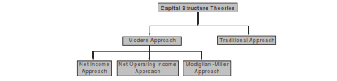

**Traditional Approach**

It is the mix of Net Income approach and Net Operating Income approach. Hence, it is also called as intermediate approach. According to the traditional approach, mix of debt and equity capital can increase the value of the firm by reducing overall cost of capital up tocertain level of debt. Traditional approach states that the K decreases only within the responsible limit of financial leverage and when reaching the minimum level, it starts increasing with financial leverage.

**Assumptions**

Capital structure theories are based on certain assumption to analysis in a single and

convenient manner:

• There are only two sources of funds used by a firm; debt and shares.

• The firm pays 100% of its earning as dividend.

• The total assets are given and do not change.

• The total finance remains constant.

• The operating profits (EBIT) are not expected to grow.

• The business risk remains constant.

• The firm has a perpetual life.

• The investors behave rationally.

**Exercise 1**

ABC Ltd., needs Rs. 30,00,000 for the installation of a new factory. The new factory

expects to yield annual earnings before interest and tax (EBIT) of Rs.5,00,000. In choosing a financial plan, ABC Ltd., has an objective of maximizing earnings per share (EPS).

The company proposes to issuing ordinary shares and raising debit of Rs. 3,00,000 and Rs. 10,00,000 of Rs. 15,00,000. The current market price per share is Rs. 250 and is expected to drop to Rs. 200 if the funds are borrowed in excess of Rs. 12,00,000. Funds can be raised at the following rates.

–up to Rs. 3,00,000 at 8%

–over Rs. 3,00,000 to Rs. 15,000,00 at 10%

–over Rs. 15,00,000 at 15%

Assuming a tax rate of 50% advise the company.

**Solution**

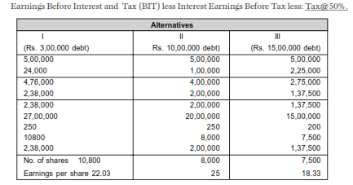

The secure alternative which gives the highest earnings per share is the best. Therefore the company is advised to revise Rs. 10,00,000 through debt amount Rs. 20,00,000 through ordinary shares.

**Exercise 2**

Compute the market value of the firm, value of shares and the average cost of capital from the following information.

Net operating income Rs. 1,00,000

Total investment Rs. 5,00,000

Equity capitalization Rate:

(a) If the firm uses no debt 10%

(b) If the firm uses Rs. 25,000 debentures 11%

(c) If the firm uses Rs. 4,00,000 debentures 13%

Assume that Rs. 5,00,000 debentures can be raised at 6% rate of interest whereas

Rs. 4,00,000 debentures can be raised at 7% rate of interest.

**Solution**

Computation of market value of firm value of shares and the average cost of capital.

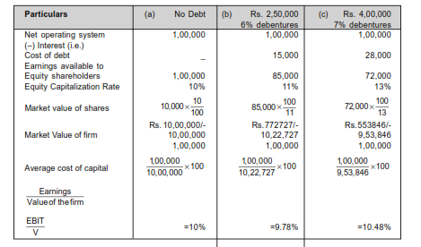

**Comments**

From the above data, if debt of Rs. 2,50,000 is used, the value of the firm increases and the overall cost of capital decreases. But, if more debt is used to finance in place of equity i.e.,

Rs. 4,00,000 debentures, the value of the firm decreases and the overall cost of capital

increases.

**Net Income (NI) Approach**

Net income approach suggested by the Durand. According to this approach, the capital

structure decision is relevant to the valuation of the firm. In other words, a change in the capital structure leads to a corresponding change in the overall cost of capital as well as the total value of the firm.

According to this approach, use more debt finance to reduce the overall cost of capital

and increase the value of firm.

Net income approach is based on the following three important assumptions:

1. There are no corporate taxes.

2. The cost debt is less than the cost of equity.

3. The use of debt does not change the risk perception of the investor.

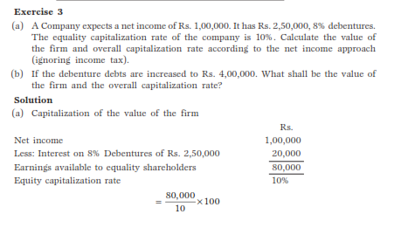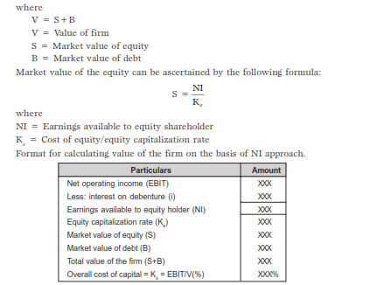

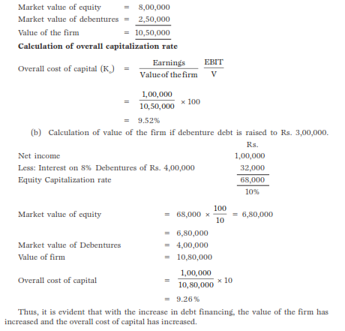

**Net Operating Income (NOI) Approach**

Another modern theory of capital structure, suggested by **Durand**. This is just the opposite to the Net Income approach. According to this approach, Capital Structure decision is irrelevant to the valuation of the firm. The market value of the firm is not at all affected by the capital structure changes.

According to this approach, the change in capital structure will not lead to any change

in the total value of the firm and market price of shares as well as the overall cost of capital.

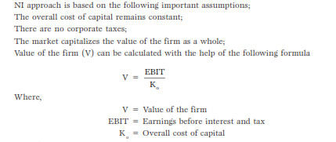

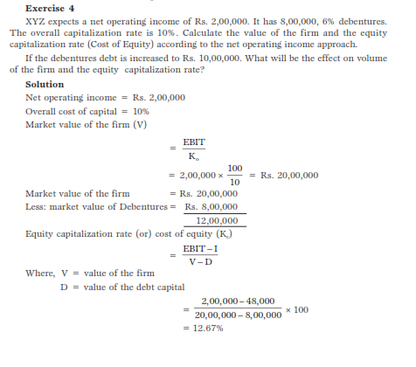

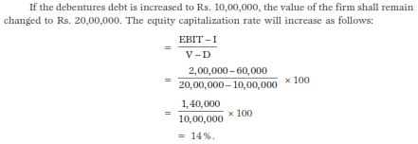

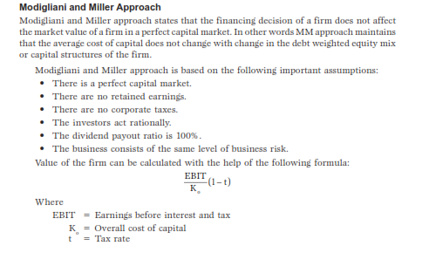

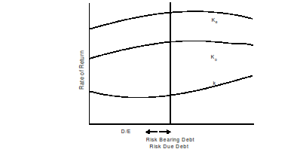

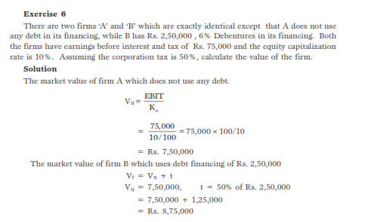

**7. EXAMINE COST OF CAPITAL?**

Cost of capital is an integral part of investment decision as it is used to measure the worth of investment proposal provided by the business concern. It is used as a discount rate in determining the present value of future cash flows associated with capital projects. Cost of capital is also called as cut-off rate, target rate, hurdle rate and required rate of return. When the firms are using different sources of finance, the finance manager must take careful decision with regard to the cost of capital; because it is closely associated with the value of the firm and the earning capacity of the firm.

**Meaning of Cost of Capital**

Cost of capital is the rate of return that a firm must earn on its project investments to

maintain its market value and attract funds. Cost of capital is the required rate of return on its investments which belongs to equity, debt and retained earnings. If a firm fails to earn return at the expected rate, the market value of the shares will fall and it will result in the reduction of overall wealth of the shareholders.

**Definitions**

The following important definitions are commonly used to understand the meaning and concept of the cost of capital.

According to the definition of **John J. Hampton** “ Cost of capital is the rate of return

the firm required from investment in order to increase the value of the firm in the market place”.

According to the definition of **Solomon Ezra,** “Cost of capital is the minimum required

rate of earnings or the cut-off rate of capital expenditure”.

**CLASSIFICATION OF COST OF CAPITAL**

Cost of capital may be classified into the following types on the basis of nature and usage:

• Explicit and Implicit Cost.

• Average and Marginal Cost.

• Historical and Future Cost.

• Specific and Combined Cost.

**Explicit and Implicit Cost**

The cost of capital may be explicit or implicit cost on the basis of the computation of cost of capital.

Explicit cost is the rate that the firm pays to procure financing. This may be calculated

with the help of the following equation;



Where, CI o = initial cash inflow

C = outflow in the period concerned

N = duration for which the funds are provided

T = tax rate

Implicit cost is the rate of return associated with the best investment opportunity for the firm and its shareholders that will be forgone if the projects presently under consideration by the firm were accepted.

**Average and Marginal Cost**

Average cost of capital is the weighted average cost of each component of capital employed by the company. It considers weighted average cost of all kinds of financing such as equity,debt, retained earnings etc.

Marginal cost is the weighted average cost of new finance raised by the company. It is

the additional cost of capital when the company goes for further raising of finance.

**Historical and Future Cost**

Historical cost is the cost which as already been incurred for financing a particular project. It is based on the actual cost incurred in the previous project.

Future cost is the expected cost of financing in the proposed project. Expected cost is

calculated on the basis of previous experience.

**Specific and Combine Cost**

The cost of each sources of capital such as equity, debt, retained earnings and loans is

called as specific cost of capital. It is very useful to determine the each and every specific source of capital.

The composite or combined cost of capital is the combination of all sources of capital.

It is also called as overall cost of capital. It is used to understand the total cost associated

with the total finance of the firm.

**IMPORTANCE OF COST OF CAPITAL**

Computation of cost of capital is a very important part of the financial management to

decide the capital structure of the business concern.

**Importance to Capital Budgeting Decision**

Capital budget decision largely depends on the cost of capital of each source. According to net present value method, present value of cash inflow must be more than the present value of cash outflow. Hence, cost of capital is used to capital budgeting decision.

**Importance to Structure Decision**

Capital structure is the mix or proportion of the different kinds of long term securities.

A firm uses particular type of sources if the cost of capital is suitable. Hence, cost of capital helps to take decision regarding structure.

**Importance to Evolution of Financial Performance**

Cost of capital is one of the important determine which affects the capital budgeting, capital structure and value of the firm. Hence, it helps to evaluate the financial performance of the firm.

**Importance to Other Financial Decisions**

Apart from the above points, cost of capital is also used in some other areas such as, market value of share, earning capacity of securities etc. hence, it plays a major part in the financial management.

**COMPUTATION OF COST OF CAPITAL**

Computation of cost of capital consists of two important parts:

1. Measurement of specific costs

2. Measurement of overall cost of capital

**Measurement of Cost of Capital**

It refers to the cost of each specific sources of finance like:

• Cost of equity

• Cost of debt

• Cost of preference share

• Cost of retained earnings

**Cost of Equity**

Cost of equity capital is the rate at which investors discount the expected dividends of the firm to determine its share value.

Conceptually the cost of equity capital (K) defined as the “Minimum rate of return

that a firm must earn on the equity financed portion of an investment project in order to

leave unchanged the market price of the shares”.

Cost of equity can be calculated from the following approach:

• Dividend price (D/P) approach

• Dividend price plus growth (D/P + g) approach

• Earning price (E/P) approach

• Realized yield approach.

**Dividend Price Approach**

The cost of equity capital will be that rate of expected dividend which will maintain the

present market price of equity shares.

Dividend price approach can be measured with the help of the following formula:

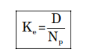

Where,

K = Cost of equity capital

D = Dividend per equity share

N e = Net proceeds of an equity share

**Exercise 1**

A company issues 10,000 equity shares of Rs. 100 each at a premium of 10%. The

company has been paying 25% dividend to equity shareholders for the past five years and expects to maintain the same in the future also. Compute the cost of equity capital. Will it make any difference if the market price of equity share is Rs. 175?

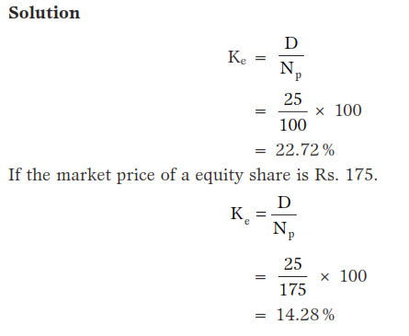

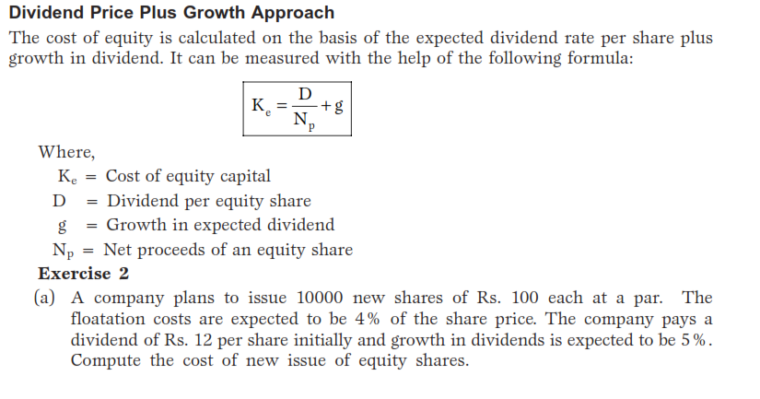

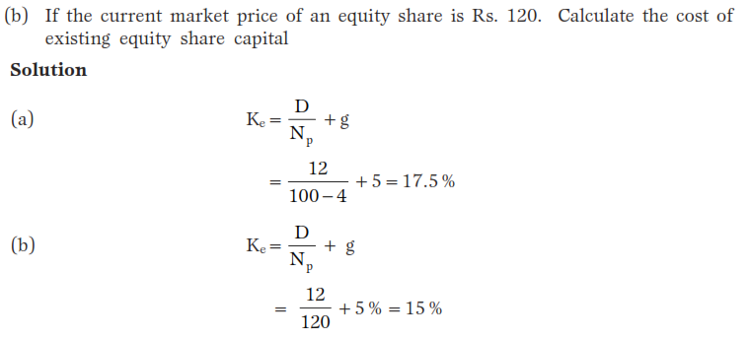

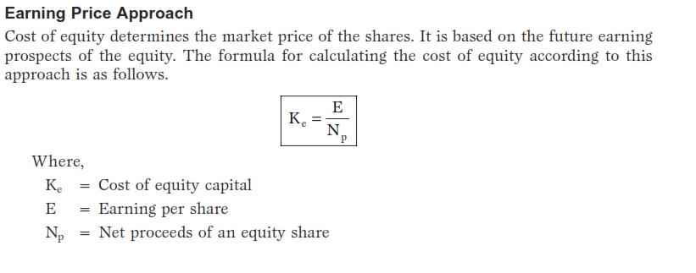

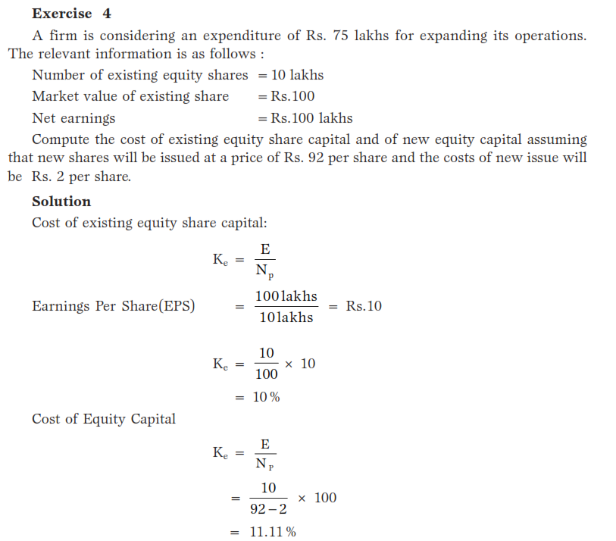

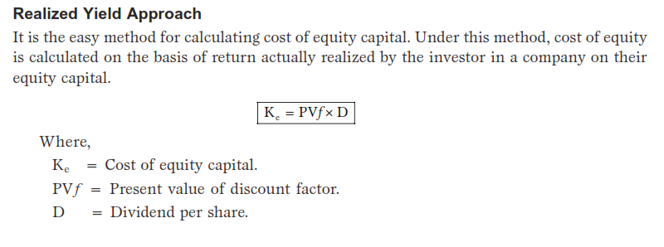

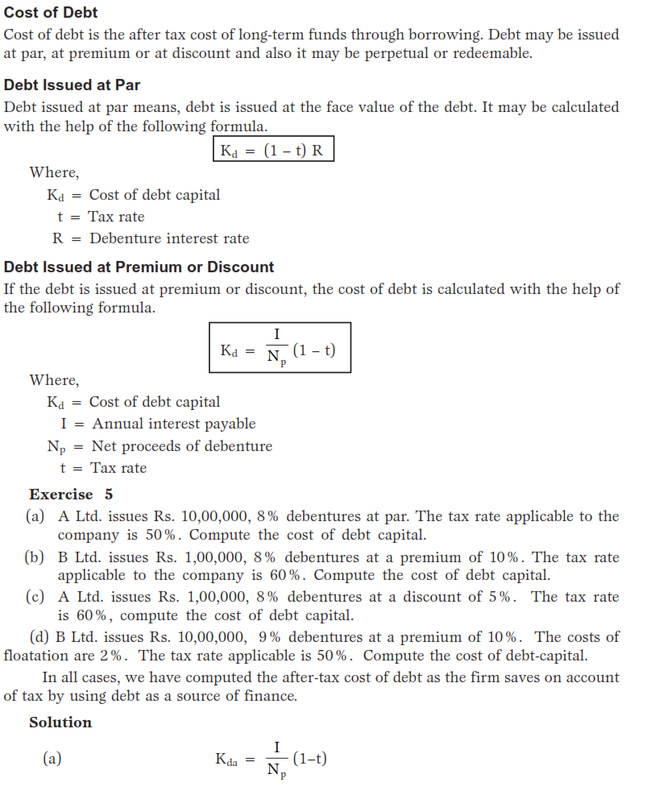

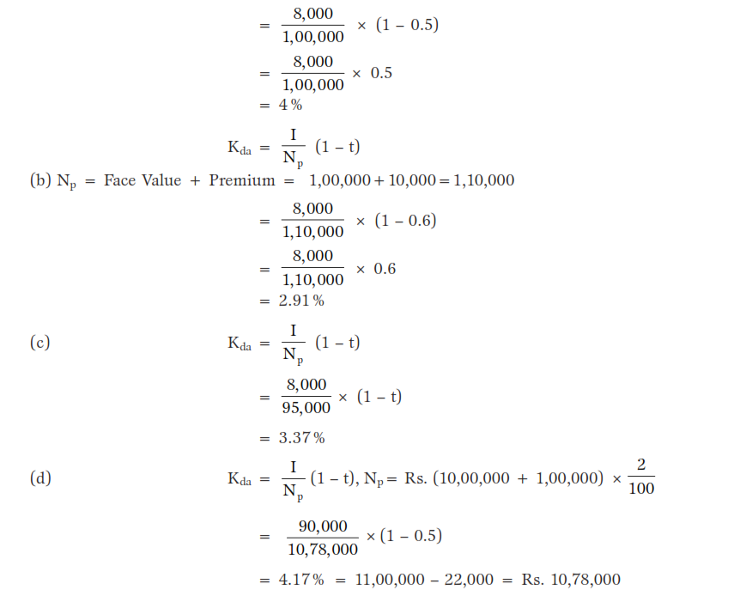

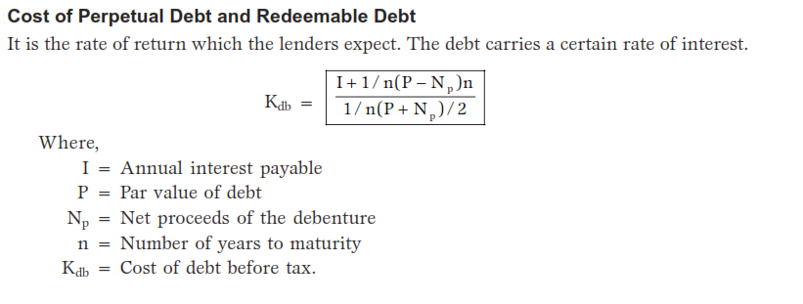

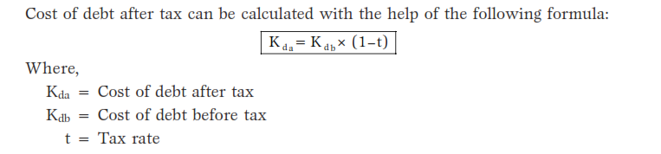

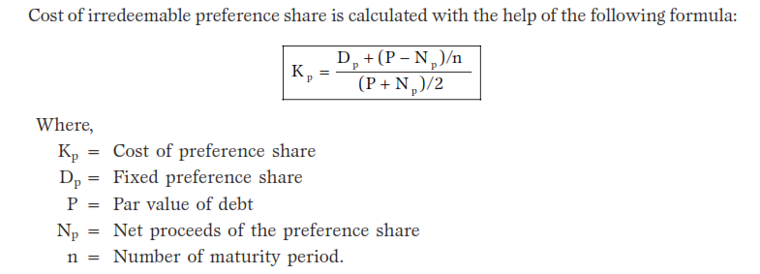 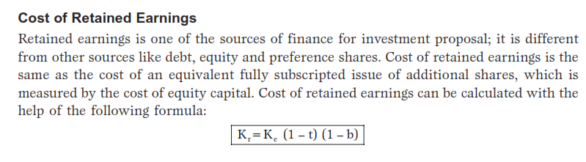 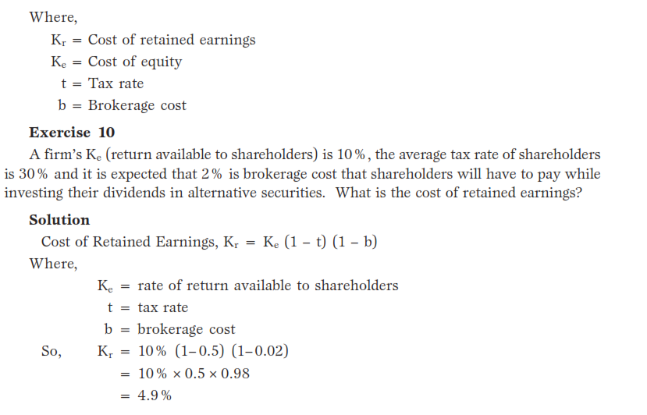

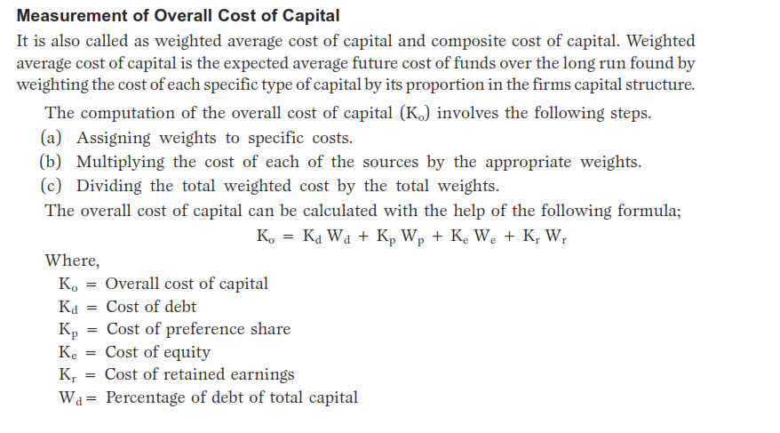 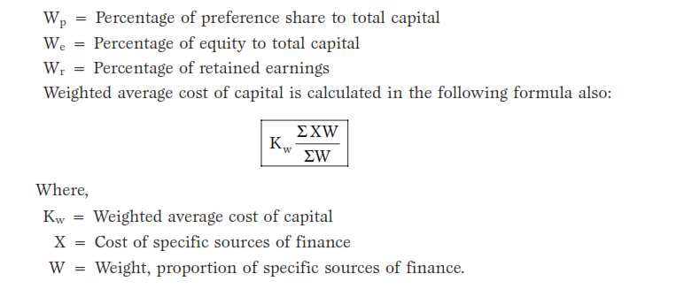 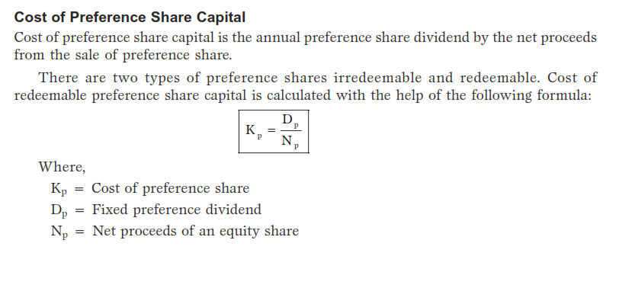

**8. WHAT IS THE MEANING OF LEVERAGE? EXPLAIN THE TYPES OF LEVERAGE S?**

Financial decision is one of the integral and important parts of financial management in

any kind of business concern. A sound financial decision must consider the board coverage of the financial mix (Capital Structure), total amount of capital (capitalization) and cost of capital (K ). Capital structure is one of the significant things for the management, since it influences the debt equity mix of the business concern, which affects the shareholder’s return and risk. Hence, deciding the debt-equity mix plays a major role in the part of the value of the company and market value of the shares. The debt equity mix of the company can be examined with the help of leverage.

The concept of leverage is discussed in this part. Types and effects of leverage is discussed in the part of EBIT and EPS.

**Meaning of Leverage**

The term leverage refers to an increased means of accomplishing some purpose. Leverage is used to lifting heavy objects, which may not be otherwise possible. In the financial point of view, leverage refers to furnish the ability to use fixed cost assets or funds to increase the return to its shareholders.

**Definition of Leverage**

**James Horne** has defined leverage as, “the employment of an asset or fund for which the firm pays a fixed cost or fixed return.

**Types of Leverage**

Leverage can be classified into three major headings according to the nature of the finance mix of the company.

The company may use finance or leverage or operating leverage, to increase the EBIT

and EPS.

**OPERATING LEVERAGE**

The leverage associated with investment activities is called as operating leverage. It is caused due to fixed operating expenses in the company. Operating leverage may be defined as the company’s ability to use fixed operating costs to magnify the effects of changes in sales on its earnings before interest and taxes. Operating leverage consists of two important costs viz., fixed cost and variable cost. When the company is said to have a high degree of operating leverage if it employs a great amount of fixed cost and smaller amount of variable cost. Thus, the degree of operating leverage depends upon the amount of various cost structure. Operating leverage can be determined with the help of a break even analysis.

Operating leverage can be calculated with the help of the following formula:

Where,

OL = Operating Leverage

C = Contribution

OP = Operating Profits

OL =COP

**Degree of Operating Leverage**

The degree of operating leverage may be defined as percentage change in the profits resulting from a percentage change in the sales. It can be calculated with the help of the following

**formula:**

DOL = Percentage change in profits/ Percentage change insales

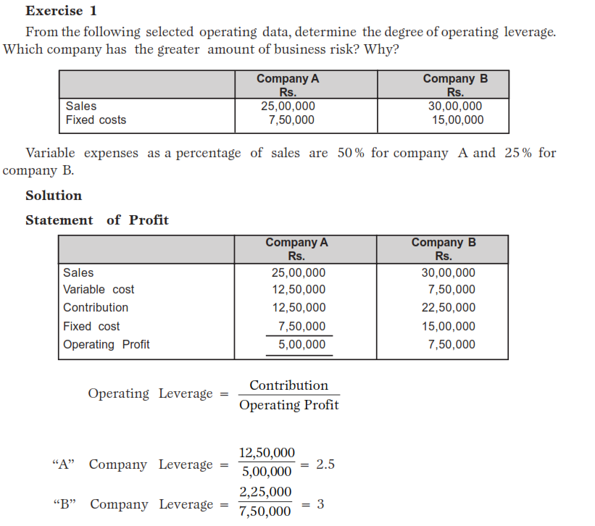

**Comments**

Operating leverage for B Company is higher than that of A Company; B Company has a

higher degree of operating risk. The tendency of operating profit may vary portionately with sales, is higher for B Company as compared to A Company.

**Uses of Operating Leverage**

* Operating leverage is one of the techniques to measure the impact of changes in sales
* which lead for change in the profits of the company.
* If any change in the sales, it will lead to corresponding changes in profit.
* Operating leverage helps to identify the position of fixed cost and variable cost.
* Operating leverage measures the relationship between the sales and revenue of the company during a particular period.
* Operating leverage helps to understand the level of fixed cost which is invested in the operating expenses of business activities.
* Operating leverage describes the over all position of the fixed operating cost.

**FINANCIAL LEVERAGE**

Leverage activities with financing activities is called financial leverage. Financial leverage represents the relationship between the company’s earnings before interest and taxes (EBIT) or operating profit and the earning available to equity shareholders.

Financial leverage is defined as “the ability of a firm to use fixed financial charges to

magnify the effects of changes in EBIT on the earnings per share”. It involves the use of

funds obtained at a fixed cost in the hope of increasing the return to the shareholders.

“The use of long-term fixed interest bearing debt and preference share capital along with share capital is called financial leverage or trading on equity”.

Financial leverage may be favourable or unfavourable depends upon the use of fixed

cost funds. Favourable financial leverage occurs when the company earns more on the assets purchased with the funds, then the fixed cost of their use. Hence, it is also called as positive financial leverage.

Unfavourable financial leverage occurs when the company does not earn as much as

the funds cost. Hence, it is also called as negative financial leverage.

Financial leverage can be calculated with the help of the following formula:

Where,

FL = Financial leverage

FL =

OP = Operating profit (EBIT)

PBT = Profit before tax.

OP

PBT

**Degree of Financial Leverage**

Degree of financial leverage may be defined as the percentage change in taxable profit as a result of percentage change in earning before interest and tax (EBIT). This can be calculated by the following formula

DFL= Percentage change in taxable Income/ Precentage change in EBIT

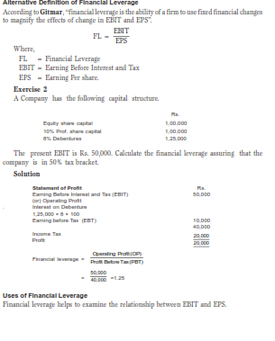

**Uses of Financial Leverage**

Financial leverage helps to examine the relationship between EBIT and EPS.

Financial leverage measures the percentage of change in taxable income to the percentage change in EBIT.

Financial leverage locates the correct profitable financial decision regarding capital

structure of the company.

Financial leverage is one of the important devices which is used to measure the fixed

cost proportion with the total capital of the company.

If the firm acquires fixed cost funds at a higher cost, then the earnings from those

assets, the earning per share and return on equity capital will decrease.

The impact of financial leverage can be understood with the help of the following

**Exercise.**

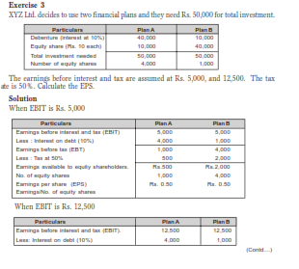

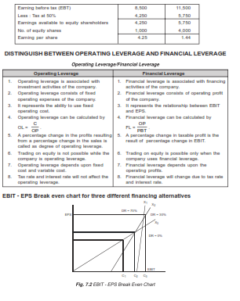



**Financial BEP**

3 It is the level of EBIT which covers all fixed financing costs of the company. It is the level of EBIT at which EPS is zero.

**Indifference Point**

It is the point at which different sets of debt ratios (percentage of debt to total capital employed in the company) gives the same EPS.

**COMBINED LEVERAGE**

When the company uses both financial and operating leverage to magnification of any

change in sales into a larger relative changes in earning per share. Combined leverage is

also called as composite leverage or total leverage.

Combined leverage express the relationship between the revenue in the account of

sales and the taxable income.

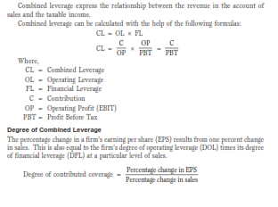

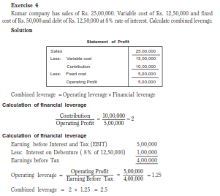

**WORKING CAPITAL LEVERAGE**

One of the new models of leverage is working capital leverage which is used to locate the investment in working capital or current assets in the company.

Working capital leverage measures the sensitivity of return in investment of charges in

the level of current assets.

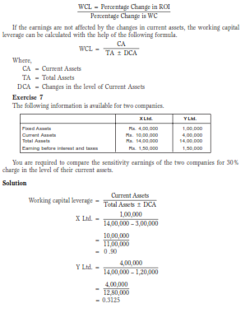

Looking at the working capital leverage of the two companies, we can say that the

sensitivity of earnings for charge on the level of current assets of X Ltd. is a greater than of Y Ltd.

**9.WHAT IS THE MEANING OF DIVIDEND ? EXPLAIN DIVIDEND TYPES ?**

The financial manager must take careful decisions on how the profit should be distributed among shareholders. It is very important and crucial part of the business concern, because these decisions are directly related with the value of the business concern and shareholder’s wealth. Like financing decision and investment decision, dividend decision is also a major part of the financial manager. When the business concerns decide dividend policyhave to consider certain factors such as retained earnings and the nature of shareholder of the business concern.

**Meaning of Dividend**

Dividend refers to the business concerns net profits distributed among the shareholders. It may also be termed as the part of the profit of a business concern, which is distributed among its shareholders.

According to the **Institute of Chartered Accountant of India**, dividend is defined as

“a distribution to shareholders out of profits or reserves available for this purpose”.

**TYPES OF DIVIDEND/ FORM OF DIVIDEND**

Dividend may be distributed among the shareholders in the form of cash or stock. HenceDividends are classified into:

A. Cash dividend

B. Stock dividend

C. Bond dividend

D. Property dividend

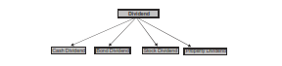

**Cash Dividend**

If the dividend is paid in the form of cash to the shareholders, it is called cash dividend. It is paid periodically out the business concerns EAIT (Earnings after interest and tax). Cash dividends are common and popular types followed by majority of the business concerns.

**Stock Dividend**

Stock dividend is paid in the form of the company stock due to raising of more finance.

Under this type, cash is retained by the business concern. Stock dividend may be bonus

issue. This issue is given only to the existing shareholders of the business concern.

**Bond Dividend**

Bond dividend is also known as script dividend. If the company does not have sufficient funds to pay cash dividend, the company promises to pay the shareholder at a future specific date with the help of issue of bond or notes.

**Property Dividend**

Property dividends are paid in the form of some assets other than cash. It will distributed under the exceptional circumstance. This type of dividend is not published in India.

**DIVIDEND DECISION**

Dividend decision of the business concern is one of the crucial parts of the financial manager, because it determines the amount of profit to be distributed among shareholders and amount of profit to be treated as retained earnings for financing its long term growth. Hence, dividend decision plays very important part in the financial management.

Dividend decision consists of two important concepts which are based on the

relationship between dividend decision and value of the firm.

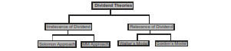

**Irrelevance of Dividend**

According to professors **Soloman, Modigliani and Miller**, dividend policy has no effect

on the share price of the company. There is no relation between the dividend rate and

value of the firm. Dividend decision is irrelevant of the value of the firm. Modigliani and Miller contributed a major approach to prove the irrelevance dividend concept.

**Modigliani and Miller’s Approach**

According to MM, under a perfect market condition, the dividend policy of the company is irrelevant and it does not affect the value of the firm.

“Under conditions of perfect market, rational investors, absence of tax discrimination

between dividend income and capital appreciation, given the firm’s investment policy, its dividend policy may have no influence on the market price of shares”.

**Assumptions**

MM approach is based on the following important assumptions:

1. Perfect capital market.

2. Investors are rational.

3. There are no tax.

4. The firm has fixed investment policy.

5. No risk or uncertainty.

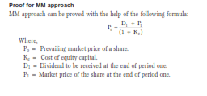

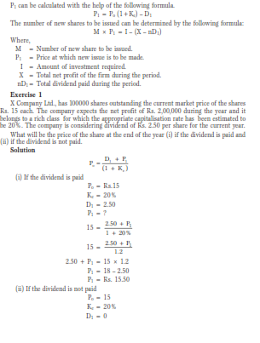



**Criticism of MM approach**

* MM approach consists of certain criticisms also. The following are the major criticisms of MM approach.
* MM approach assumes that tax does not exist. It is not applicable in the practical life of the firm.
* MM approach assumes that, there is no risk and uncertain of the investment. It is also not applicable in present day business life.
* MM approach does not consider floatation cost and transaction cost. It leads to affect the value of the firm.
* MM approach considers only single decrement rate, it does not exist in real practice.
* MM approach assumes that, investor behaves rationally. But we cannot give assurance that all the investors will behave rationally.

**RELEVANCE OF DIVIDEND**

According to this concept, dividend policy is considered to affect the value of the firm.

Dividend relevance implies that shareholders prefer current dividend and there is no direct relationship between dividend policy and value of the firm. Relevance of dividend concept is supported by two eminent persons like Walter and Gordon.

**Walter’s Model**

**Prof. James E. Walter** argues that the dividend policy almost always affects the value of

the firm. Walter model is based in the relationship between the following important factors:

• Rate of return I

• Cost of capital (k)

According to the Walter’s model, if r > k, the firm is able to earn more than what the

shareholders could by reinvesting, if the earnings are paid to them. The implication of

r > k is that the shareholders can earn a higher return by investing elsewhere. If the firm has r = k, it is a matter of indifferent whether earnings are retained or distributed.

**Assumptions**

Walters model is based on the following important assumptions:

1. The firm uses only internal finance.

2. The firm does not use debt or equity finance.

3. The firm has constant return and cost of capital.

4. The firm has 100 recent payout.

5. The firm has constant EPS and dividend.

6. The firm has a very long life.

Walter has evolved a mathematical formula for determining the value of market share.

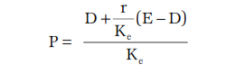

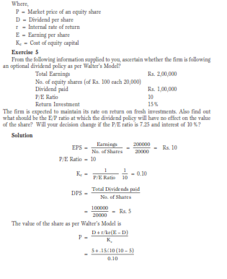

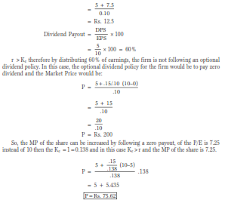

= Rs. 81.48

**Criticism of Walter’s Model**

The following are some of the important criticisms against Walter model:

Walter model assumes that there is no extracted finance used by the firm. It is not

practically applicable. There is no possibility of constant return. Return may increase or decrease, depending upon the business situation. Hence, it is applicable.

According to Walter model, it is based on constant cost of capital. But it is not applicable in the real life of the business.

**Gordon’s Model**

**Myron Gorden** suggest one of the popular model which assume that dividend policy of a firm affects its value, and it is based on the following important assumptions:

1. The firm is an all equity firm.

2. The firm has no external finance.

3. Cost of capital and return are constant.

4. The firm has perpectual life.

5. There are no taxes.

6. Constant relation ratio (g=br).

7. Cost of capital is greater than growth rate (Ke>br).

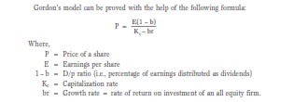



**Criticism of Gordon’s Model**

Gordon’s model consists of the following important criticisms:

Gordon model assumes that there is no debt and equity finance used by the firm. It is not applicable to present day business.and r cannot be constant in the real practice.

According to Gordon’s model, there are no tax paid by the firm. It is not practically applicable. Ke

**10. WHICH FACTORS DETERMINING DIVIDEND POLICY?**

**Profitable Position of the Firm**

Dividend decision depends on the profitable position of the business concern. When the

firm earns more profit, they can distribute more dividends to the shareholders.

**Uncertainty of Future Income**

Future income is a very important factor, which affects the dividend policy. When the

shareholder needs regular income, the firm should maintain regular dividend policy.

**Legal Constrains**

The Companies Act 1956 has put several restrictions regarding payments and declaration of dividends. Similarly, Income Tax Act, 1961 also lays down certain restrictions on payment of dividends.

**Liquidity Position**

Liquidity position of the firms leads to easy payments of dividend. If the firms have high liquidity, the firms can provide cash dividend otherwise, they have to pay stock dividend.

**Sources of Finance**

If the firm has finance sources, it will be easy to mobilise large finance. The firm shall not go for retained earnings.

**Growth Rate of the Firm**

High growth rate implies that the firm can distribute more dividend to its shareholders.

**Tax Policy**

Tax policy of the government also affects the dividend policy of the firm. When the government gives tax incentives, the company pays more dividend.

**Capital Market Conditions**

Due to the capital market conditions, dividend policy may be affected. If the capital market is prefect, it leads to improve the higher dividend.

**11. EXAMINE TYPES OF DIVIDEND POLICY?**

Dividend policy depends upon the nature of the firm, type of shareholder and profitable position. On the basis of the dividend declaration by the firm, the dividend policy may be classified under the following types:

• Regular dividend policy

• Stable dividend policy

• Irregular dividend policy

• No dividend policy.

**Regular Dividend Policy**

Dividend payable at the usual rate is called as regular dividend policy. This type of policy is suitable to the small investors, retired persons and others.

**Stable Dividend Policy**

Stable dividend policy means payment of certain minimum amount of dividend regularly. This dividend policy consists of the following three important forms:

Constant dividend per share

Constant payout ratio

Stable rupee dividend plus extra dividend.

**Irregular Dividend Policy**

When the companies are facing constraints of earnings and unsuccessful business operation, they may follow irregular dividend policy. It is one of the temporary arrangements to meet the financial problems. These types are having adequate profit. For others no dividend is distributed.

**No Dividend Policy**

Sometimes the company may follow no dividend policy because of its unfavourable working capital position of the amount required for future growth of the concerns.

**12. EXPLAIN CAPITAL BUDGETING?**

The word Capital refers to be the total investment of a company of firm in money, tangible and intangible assets. Whereas budgeting defined by the “**Rowland** and **William**” it may be said to be the art of building budgets. Budgets are a blue print of a plan and action expressed in quantities and manners.

The examples of capital expenditure:

1. Purchase of fixed assets such as land and building, plant and machinery, good will, etc.

2. The expenditure relating to addition, expansion, improvement and alteration to the fixed assets.

3. The replacement of fixed assets.

4. Research and development project.

**Definitions**

According to the definition of **Charles T. Hrongreen,** “capital budgeting is a long-term

planning for making and financing proposed capital out lays.

It is clearly explained in the above definitions that a firm’s scarce financial resources

are utilizing the available opportunities. The overall objectives of the company from is to maximize the profits and minimize the expenditure of cost.

**Need and Importance of Capital Budgeting**

**1. Huge investments:** Capital budgeting requires huge investments of funds, but

the available funds are limited, therefore the firm before investing projects, plan are control its capital expenditure.

**2. Long-term:** Capital expenditure is long-term in nature or permanent in nature.

Therefore financial risks involved in the investment decision are more. If higher risks are involved, it needs careful planning of capital budgeting.

**3. Irreversible:** The capital investment decisions are irreversible, are not changed

back. Once the decision is taken for purchasing a permanent asset, it is very difficult to dispose off those assets without involving huge losses.

**4. Long-term effect:** Capital budgeting not only reduces the cost but also increases

the revenue in long-term and will bring significant changes in the profit of the company by avoiding over or more investment or under investment. Over investments leads to be unable to utilize assets or over utilization of fixed assets.

Therefore before making the investment, it is required carefully planning and

analysis of the project thoroughly.

**CAPITAL BUDGETING PROCESS**

Capital budgeting is a difficult process to the investment of available funds. The benefit will attained only in the near future but, the future is uncertain. However, the following steps followed for capital budgeting, then the process may be easier are.

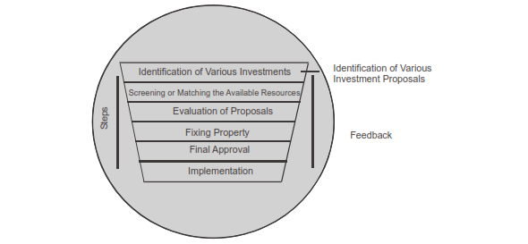

**1. Identification of various investments proposals:** The capital budgeting may have various investment proposals. The proposal for the investment opportunities may be defined from the top management or may be even from the lower rank. The heads of various department analyse the various investment decisions, and will select proposals submitted to the planning committee of competent authority.

**2. Screening or matching the proposals:** The planning committee will analyse the various proposals and screenings. The selected proposals are considered with the available resources of the concern. Here resources referred as the financial part of the proposal. This reduces the gap between the resources and the investment cost.

**3. Evaluation:** After screening, the proposals are evaluated with the help of various methods, such as pay back period proposal, net discovered present value method, accounting rate of return and risk analysis. Each method of evaluation used in detail in the later part of this chapter.

The proposals are evaluated by.

(a) Independent proposals

(b) Contingent of dependent proposals

(c) Partially exclusive proposals.

Independent proposals are not compared with another proposals and the same may be accepted or rejected. Whereas higher proposals acceptance depends upon the other one or more proposals. For example, the expansion of plant machinery leads to constructing of new building, additional manpower etc. Mutually exclusive projects are those which competed with other proposals and to implement the proposals after considering the risk and return, market demand etc.

**4. Fixing property:** After the evolution, the planning committee will predict which proposals will give more profit or economic consideration. If the projects or proposals are not suitable for the concern’s financial condition, the projects are rejected without considering other nature of the proposals.

**5. Final approval:** The planning committee approves the final proposals, with the help of the following:

(a) Profitability

(b) Economic constituents

(c) Financial violability

(d) Market conditions.

The planning committee prepares the cost estimation and submits to the management.

**6. Implementing:** The competent autherity spends the money and implements the proposals. While implementing the proposals, assign responsibilities to the proposals, assign responsibilities for completing it, within the time allotted and reduce the cost for this purpose. The network techniques used such as PERT and CPM. It helps the management for monitoring and containing the implementation of the proposals.

**7. Performance review of feedback:** The final stage of capital budgeting is actual results compared with the standard results. The adverse or unfavourable results identified and removing the various difficulties of the project. This is helpful for the future of the proposals.

**KINDS OF CAPITAL BUDGETING DECISIONS**

The overall objective of capital budgeting is to maximize the profitability. If a firm

concentrates return on investment, this objective can be achieved either by increasing the revenues or reducing the costs. The increasing revenues can be achieved by expansion or the size of operations by adding a new product line. Reducing costs mean representing obsolete return on assets.

**METHODS OF CAPITAL BUDGETING OF EVALUATION**

By matching the available resources and projects it can be invested. The funds available

are always living funds. There are many considerations taken for investment decision process such as environment and economic conditions.

The methods of evaluations are classified as follows:

**(A) Traditional methods (or Non-discount methods)**

(i) Pay-back Period Methods

(ii) Post Pay-back Methods

(iii) Accounts Rate of Return

**(B) Modern methods (or Discount methods)**

(i) Net Present Value Method

(ii) Internal Rate of Return Method

(iii) Profitability Index Method

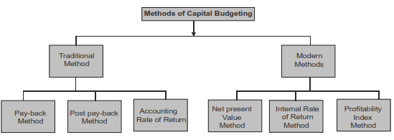

**Pay-back Period**

Pay-back period is the time required to recover the initial investment in a project.

(It is one of the non-discounted cash flow methods of capital budgeting).

Pay-back period = Initial investment/ Annual cash inflows

**Merits of Pay-back method**

The following are the important merits of the pay-back method:

1. It is easy to calculate and simple to understand.

2. Pay-back method provides further improvement over the accounting rate return.

3. Pay-back method reduces the possibility of loss on account of obsolescence.

**Demerits**

1. It ignores the time value of money.

2. It ignores all cash inflows after the pay-back period.

3. It is one of the misleading evaluations of capital budgeting.

**Accept / Reject criteria**

If the actual pay-back period is less than the predetermined pay-back period, the project

would be accepted. If not, it would be rejected.

**Exercise 1**

Project cost is Rs. 30,000 and the cash inflows are Rs. 10,000, the life of the project is

5 years. Calculate the pay-back period.

**Solution** =Rs. 30,000 /Rs. 10,000 = 3 Years

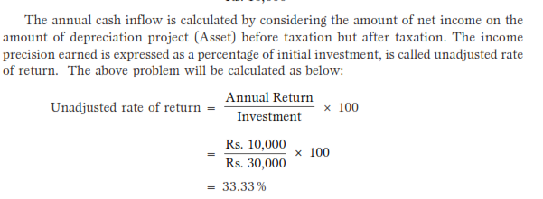

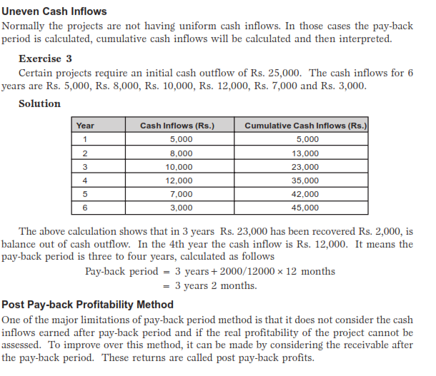

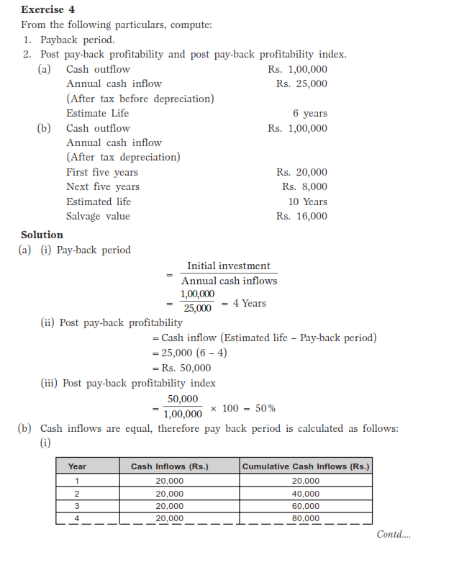

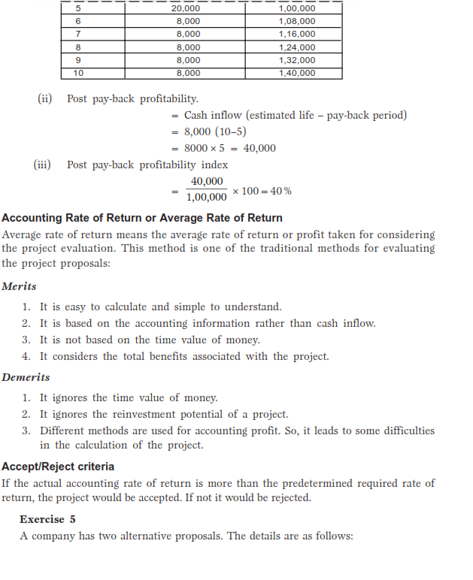

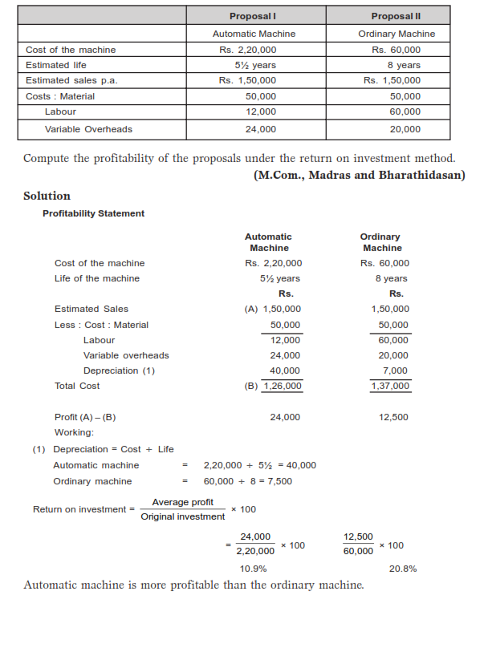

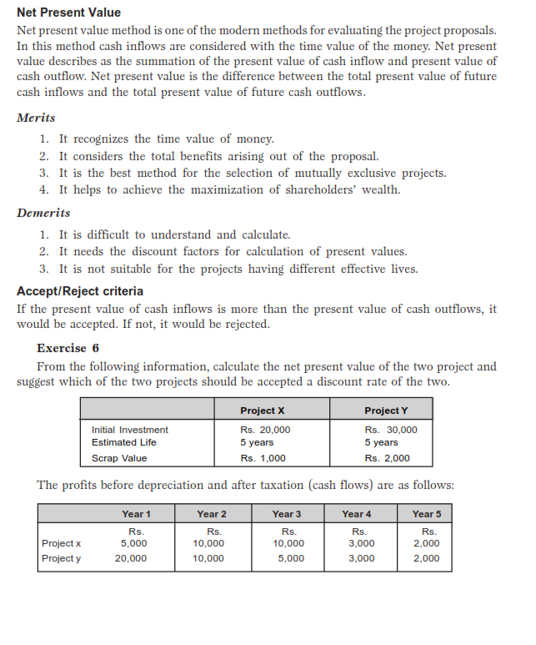

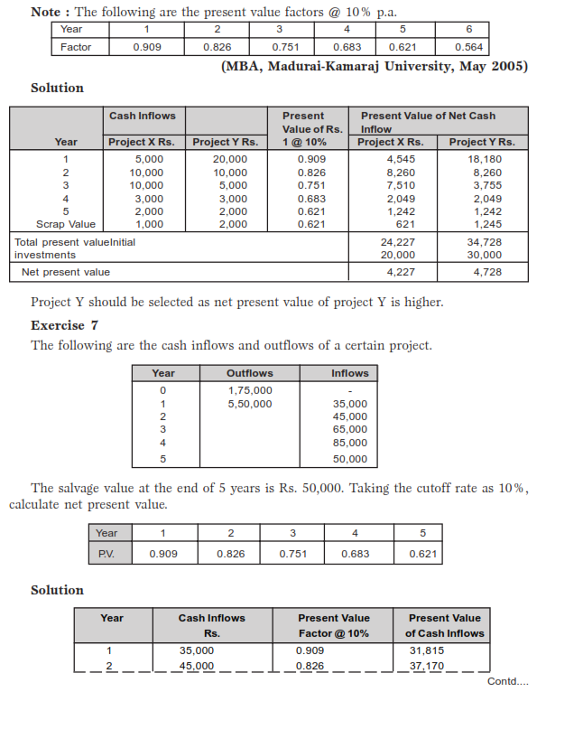

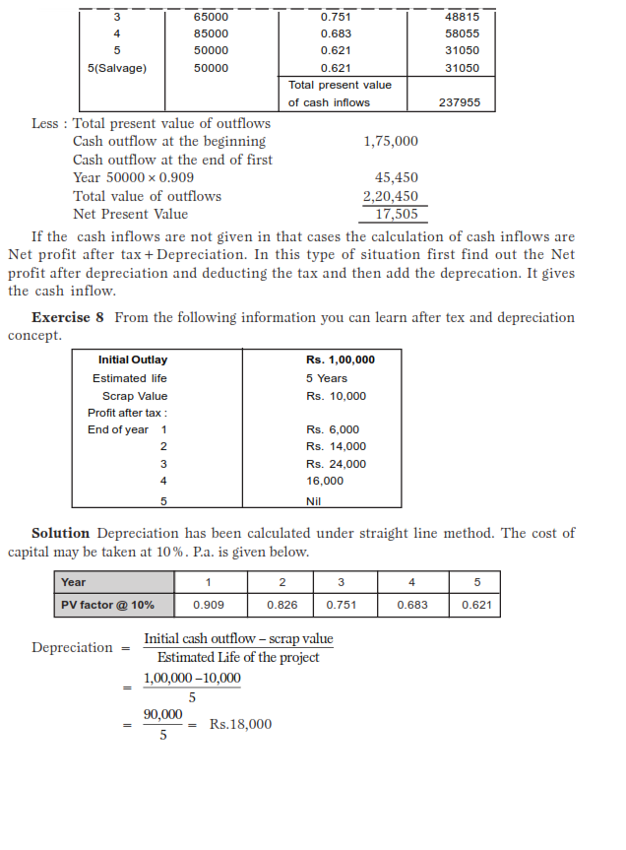

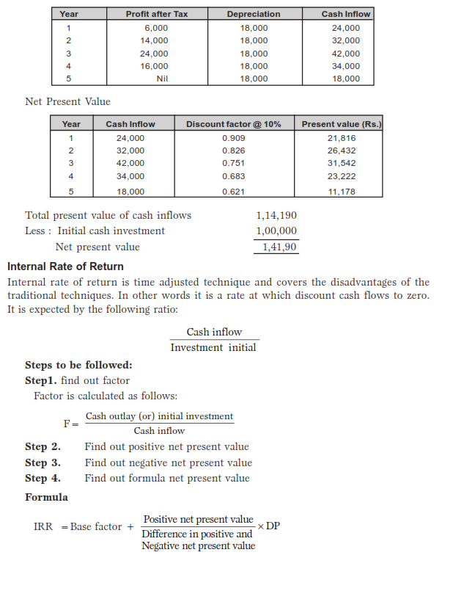

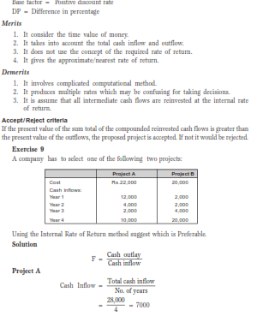

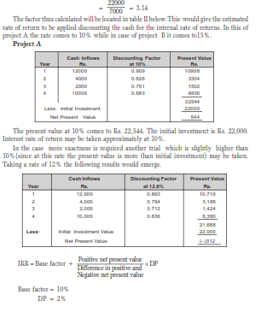

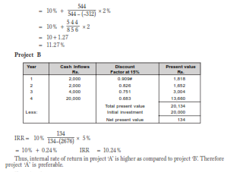

**RISK AND UNCERTAINLY IN CAPITAL BUDGETING**

Capital budgeting requires the projection of cash inflow and outflow of the future.

The future in always uncertain, estimate of demand, production, selling price, cost etc.,

cannot be exact.

For example: The product at any time it become obsolete therefore, the future in unexpected. The following methods for considering the accounting of risk in capital budgeting.

Various evaluation methods are used for risk and uncertainty in capital budgeting are as follows:

(i) Risk-adjusted cut off rate (or method of varying discount rate)

(ii) Certainly equivalent method.

(iii) Sensitivity technique.

(iv) Probability technique

(v) Standard deviation method.

(vi) Co-efficient of variation method.

(vii) Decision tree analysis.

**(i) Risk-adjusted cutoff rate (or Method of varying)**

This is one of the simplest method while calculating the risk in capital budgeting

increase cut of rate or discount factor by certain percentage an account of risk.

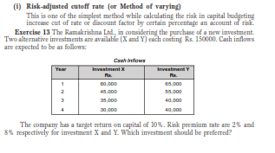

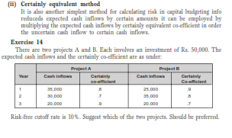

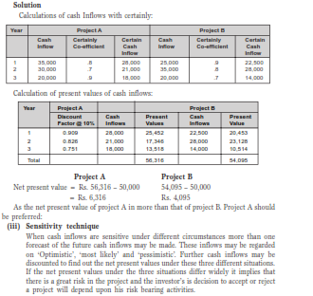

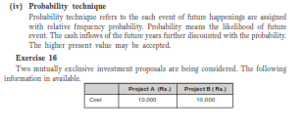

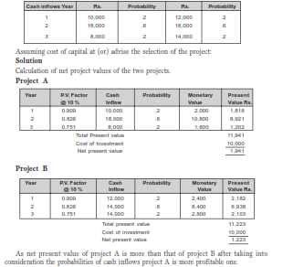

**13. WHAT IS WORKING CAPITAL? EXPLAIN THE TYPES OF WORKING CAPITAL?**

Working capital management is also one of the important parts of the financial management. It is concerned with short-term finance of the business concern which is a closely related trade between profitability and liquidity. Efficient working capital management leads to improve the operating performance of the business concern and it helps to meet the shortterm liquidity.

Hence, study of working capital management is not only an important part of financial management but also are overall management of the business concern.

Working capital is described as the capital which is not fixed but the more common uses of the working capital is to consider it as the difference between the book value of current assets and current liabilities.

This chapter deals with the following important aspects of the working capital

management.

• Meaning of Working Capital

• Concept of Working Capital

• Types of Working Capital

• Needs of Working Capital

• Factors determining Working Capital

• Computation of Working Capital

• Sources of Working Capital

• Working Capital Management Policy

• Working Capital and Banking Committee

**MEANING OF WORKING CAPITAL**

Capital of the concern may be divided into two major headings.



**Definitions**

According to the definition of **Mead, Baker and Malott,** “Working Capital means Current Assets”.

**CONCEPT OF WORKING CAPITAL**

Working capital can be classified or understood with the help of the following two important

concepts.



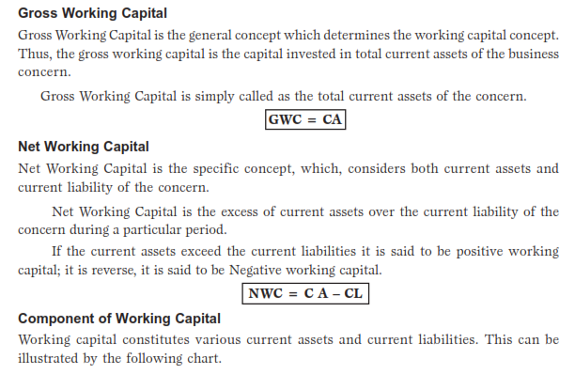

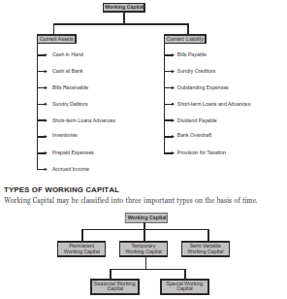

**Permanent Working Capital**

It is also known as Fixed Working Capital. It is the capital; the business concern must

maintain certain amount of capital at minimum level at all times. The level of Permanent Capital depends upon the nature of the business. Permanent or Fixed Working Capital will not change irrespective of time or volume of sales.

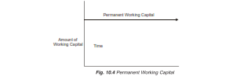

**Temporary Working Capital**

It is also known as variable working capital. It is the amount of capital which is required to meet the Seasonal demands and some special purposes. It can be further classified into Seasonal Working Capital and Special Working Capital.

The capital required to meet the seasonal needs of the business concern is called as

Seasonal Working Capital. The capital required to meet the special exigencies such as

launching of extensive marketing campaigns for conducting research, etc.

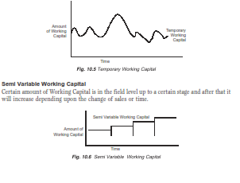

**NEEDS OF WORKING CAPITAL**

Working Capital is an essential part of the business concern. Every business concern must maintain certain amount of Working Capital for their day-to-day requirements and meet the short-term obligations. Working Capital is needed for the following purposes.

**1. Purchase of raw materials and spares:** The basic part of manufacturing process is, raw materials. It should purchase frequently according to the needs of the business concern. Hence, every business concern maintains certain amount as Working Capital to purchase raw materials, components, spares, etc.

**2. Payment of wages and salary:** The next part of Working Capital is payment of wages and salaries to labour and employees. Periodical payment facilities make employees perfect in their work. So a business concern maintains adequate the amount of working capital to make the payment of wages and salaries.

**3. Day-to-day expenses:** A business concern has to meet various expenditures regarding the operations at daily basis like fuel, power, office expenses, etc.

**4. Provide credit obligations:** A business concern responsible to provide credit facilities to the customer and meet the short-term obligation. So the concern must provide adequate Working Capital.

**Working Capital Position/ Balanced Working Capital Position.**

A business concern must maintain a sound Working Capital position to improve the efficiency of business operation and efficient management of finance. Both excessive and inadequate

Working Capital lead to some problems in the business concern.

**A. Causes and effects of excessive working capital.**

(i) Excessive Working Capital leads to unnecessary accumulation of raw materials, components and spares.

(ii) Excessive Working Capital results in locking up of excess Working Capital.

(iii) It creates bad debts, reduces collection periods, etc.

(iv) It leads to reduce the profits.

**B. Causes and effects of inadequate working capital**

(i) Inadequate working capital cannot buy its requirements in bulk order.

(ii) It becomes difficult to implement operating plans and activate the firm’s profit target.

(iii) It becomes impossible to utilize efficiently the fixed assets.

(iv) The rate of return on investments also falls with the shortage of Working Capital.

(v) It reduces the overall operation of the business.

**FACTORS DETERMINING WORKING CAPITAL REQUIREMENTS**

Working Capital requirements depends upon various factors. There are no set of rules or formula to determine the Working Capital needs of the business concern. The following are the major factors which are determining the Working Capital requirements.

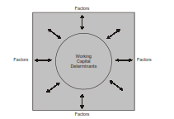

**1. Nature of business:** Working Capital of the business concerns largely depend

upon the nature of the business. If the business concerns follow rigid credit policy

and sell goods only for cash, they can maintain lesser amount of Working Capital.

A transport company maintains lesser amount of Working Capital while a construction company maintains larger amount of Working Capital.

**2. Production cycle:** Amount of Working Capital depends upon the length of the production cycle. If the production cycle length is small, they need to maintain lesser amount of Working Capital. If it is not, they have to maintain large amount of Working Capital.

**3. Business cycle:** Business fluctuations lead to cyclical and seasonal changes in the business condition and it will affect the requirements of the Working Capital. In the booming conditions, the Working Capital requirement is larger and in the depression condition, requirement of Working Capital will reduce. Better business results lead to increase the Working Capital requirements.

**4. Production policy:** It is also one of the factors which affects the Working Capital

requirement of the business concern. If the company maintains the continues production policy, there is a need of regular Working Capital. If the production policy of the company depends upon the situation or conditions, Working Capital requirement will depend upon the conditions laid down by the company.

**5. Credit policy:** Credit policy of sales and purchase also affect the Working Capital

requirements of the business concern. If the company maintains liberal credit policy to collect the payments from its customers, they have to maintain more Working Capital. If the company pays the dues on the last date it will create the cash maintenance in hand and bank.

**6. Growth and expansion:** During the growth and expansion of the business concern, Working Capital requirements are higher, because it needs some additional Working Capital and incurs some extra expenses at the initial stages.

**7. Availability of raw materials:** Major part of the Working Capital requirements are largely depend on the availability of raw materials. Raw materials are the basic components of the production process. If the raw material is not readily available, it leads to production stoppage. So, the concern must maintain adequate raw material; for that purpose, they have to spend some amount of Working Capital.

**8. Earning capacity:** If the business concern consists of high level of earning capacity, they can generate more Working Capital, with the help of cash from operation. Earning capacity is also one of the factors which determines the Working Capital requirements of the business concern.

**COMPUTATION (OR ESTIMATION) OF WORKING CAPITAL**

Working Capital requirement depends upon number of factors, which are already discussed in the previous parts. Now the discussion is on how to calculate the Working Capital needs of the business concern. It may also depend upon various factors but some of the common methods are used to estimate the Working Capital.

**A. Estimation of components of working capital method**

Working capital consists of various current assets and current liabilities. Hence, we have to estimate how much current assets as inventories required and how much cash required to meet the short term obligations. Finance Manager first estimates the assets and required Working Capital for a particular period.

**B. Percent of sales method**

Based on the past experience between Sales and Working Capital requirements, a ratio can be determined for estimating the Working Capital requirement in future. It is the simple and tradition method to estimate the Working Capital requirements. Under this method, first we have to find out the sales to Working Capital ratio and based on that we have to estimate Working Capital requirements. This method also expresses the relationship between the Sales and Working Capital.

**C. Operating cycle**

Working Capital requirements depend upon the operating cycle of the business. The operating cycle begins with the acquisition of raw material and ends with the collection of receivables.

Operating cycle consists of the following important stages:

1. Raw Material and Storage Stage, (R)

2. Work in Process Stage, (W)

3. Finished Goods Stage, (F)

4. Debtors Collection Stage, (D)

5. Creditors Payment Period Stage. (C)

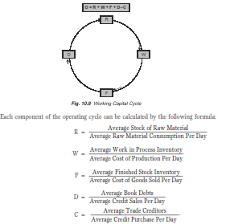

**Exercise 1**

From the following information extracted from the books of a manufacturing company,

compute the operating cycle in days and the amount of working capital required:

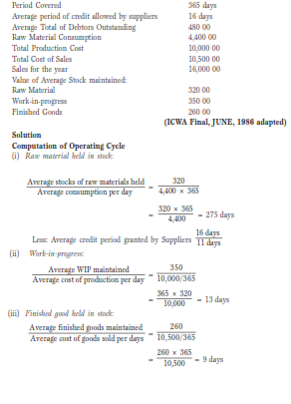

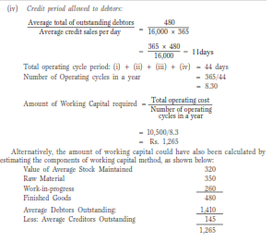

**14. EXPLAIN THE WORKING CAPITAL MANAGEMENT POLICY?**

Working Capital Management formulates policies to manage and handle efficiently; for that purpose, the management established three policies based on the relationship between Sales and Working Capital.

1. Conservative Working Capital Policy.

2. Moderate Working Capital Policy.

3. Aggressive Working Capital Policy.

**1. Conservative working capital policy:** Conservative Working Capital Policy refers

to minimize risk by maintaining a higher level of Working Capital. This type of Working Capital Policy is suitable to meet the seasonal fluctuation of the manufacturing operation.

**2. Moderate working capital policy:** Moderate Working Capital Policy refers to the

moderate level of Working Capital maintainance according to moderate level of sales.

It means one percent of change in Working Capital, that is Working Capital is equal to sales.

**3. Aggressive working capital policy:** Aggressive Working Capital Policy is one

of the high risky and profitability policies which maintains low level of Aggressive Working Capital against the high level of sales, in the business concern during a particular period.

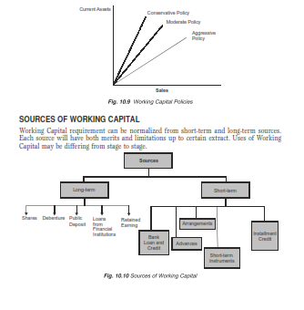

The above sources are also classified into internal sources and external sources of working capital.

Internal sources such as:

• Retained Earnings

• Reserve and Surplus

• Depreciation Funds etc.

External sources such as:

• Debentures and Public Deposits

• Loans from Banks and Financial Institutions

• Advances and Credit

• Financial arrangements like Factoring, etc.

**Determining the Finance Mix**

Determining the finance mix is an important part of working capital management. Under this decision, the relationship among risk, return and liquidity are measured and also which type of financing is suitable to meet the Working Capital requirements of the business concern. There are three basic approaches for determining an appropriate Working Capital finance mix.

1. Hedging or matching approach

2. Conservative approach

3. Aggressive approach.

**Hedging Approach**

Hedging approach is also known as matching approach. Under this approach, the

business concern can adopt a financial plan which matches the expected life of assets with the expected life of the sources of funds raised to finance assets.

When the business follows matching approach, long-term finance shall be used to fixed

assets and permanent current assets and short-term financing to finance temporary or

variable assets. Temporary Current Assets

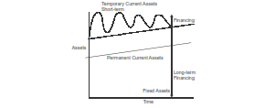

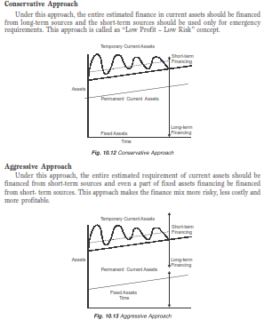

**14. WHAT IS THE INVENTORY? EXPLAIN TYPES OF INVENTORY MANAGEMENT?**

Inventories constitute the most significant part of current assets of the business concern.

It is also essential for smooth running of the business activities.

**Meaning**

The dictionary meaning of the inventory is stock of goods or a list of goods. In accounting language, inventory means stock of finished goods. In a manufacturing point of view, inventory includes, raw material, work in process, stores, etc.

**Kinds of Inventories**

Inventories can be classified into five major categories.

*A. Raw Material*

It is basic and important part of inventories. These are goods which have not yet been committed to production in a manufacturing business concern.

*B. Work in Progress*

These include those materials which have been committed to production process but have not yet been completed.

*C. Consumables*

These are the materials which are needed to smooth running of the manufacturing process.

*D. Finished Goods*

These are the final output of the production process of the business concern. It is ready for consumers.

*E. Spares*

It is also a part of inventories, which includes small spares and parts.

**Objectives of Inventory Management**

Inventory occupy 30–80% of the total current assets of the business concern. It is also

very essential part not only in the field of Financial Management but also it is closely

associated with production management. Hence, in any working capital decision regarding the inventories, it will affect both financial and production function of the concern. Hence, efficient management of inventories is an essential part of any kind of manufacturing process concern.

The major objectives of the inventory management are as follows:

• To efficient and smooth production process.

• To maintain optimum inventory to maximize the profitability.

• To meet the seasonal demand of the products

• To avoid price increase in future.

• To ensure the level and site of inventories required.

• To plan when to purchase and where to purchase

• To avoid both over stock and under stock of inventory.

**Techniques of Inventory Management**

Inventory management consists of effective control and administration of inventories.

entory control refers to a system which ensures supply of required quantity and quality

of inventories at the required time and at the same time prevent unnecessary investment in inventories. It needs the following important techniques. Inventory management techniques may be classified into various types:

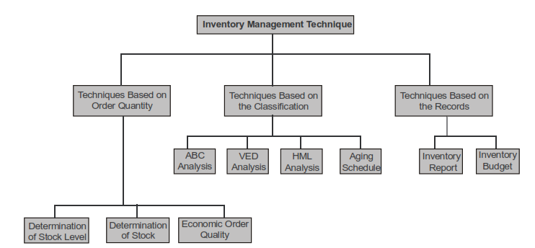

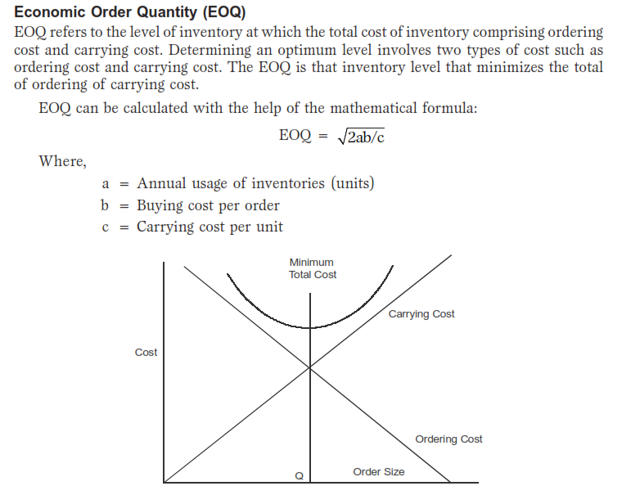

**Exercise 1**

(a) Find out the economic order quantity and the number of orders per year from

the following information:

Annual consumption: 36,000 units Purchase price per units: Rs. 54

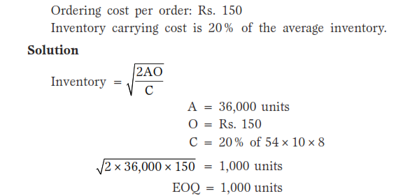

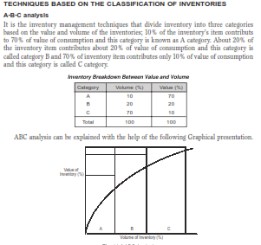

**TECHNIQUES ON THE BASIS OF RECORDS**

**A. Inventory budget**

It is a kind of functional budget which facilitates the estimated inventory required for the business concern during a particular period. This budget is prepared based on the past experience.

**B. Inventory reports**

Preparation of periodical inventory reports provides information regarding the order level, quantity to be procured and all other information related to inventories. On the basis of these reports, Management takes necessary decision regarding inventory control and Management in the business concern.

**Valuation of Inventories**

Inventories are valued at different methods depending upon the situation and nature of

manufacturing process. Some of the major methods of inventory valuation are mentioned as follows:

1. First in First Out Method (FIFO)

2. Last in First Out Method (LIFO)

3. Highest in First Out Method (HIFO)

4. Nearest in First Out Method (NIFO)

5. Average Price Method

6. Base Stock Method

7. Standard Price Method

8. Market Price Method.

**CASH MANAGEMENT**

Business concern needs cash to make payments for acquisition of resources and services

for the normal conduct of business. Cash is one of the important and key parts of the current assets.

Cash is the money which a business concern can disburse immediately without any

restriction. The term cash includes coins, currency, cheques held by the business concern and balance in its bank accounts. Management of cash consists of cash inflow and outflows, cash flow within the concern and cash balance held by the concern etc.

**Motives for Holding Cash**

1. **Transaction motive**

It is a motive for holding cash or near cash to meet routine cash requirements to finance transaction in the normal course of business. Cash is needed to make purchases of raw materials, pay expenses, taxes, dividends etc.

2. **Precautionary motive**

It is the motive for holding cash or near cash as a cushion to meet unexpected contingencies. Cash is needed to meet the unexpected situation like, floods strikes etc.

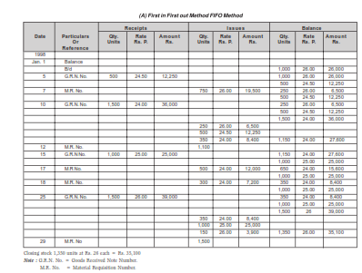

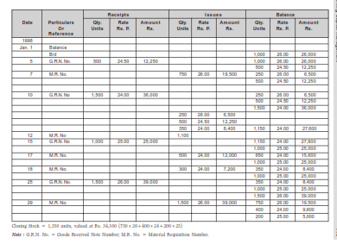

3. **Speculative motive**

It is the motive for holding cash to quickly take advantage of opportunities typically outside the normal course of business. Certain amount of cash is needed to meet an opportunity to purchase raw materials at a reduced price or make purchase at favorable prices.

4. **Compensating motive**

It is a motive for holding cash to compensate banks for providing certain services or loans. Banks provide variety of services to the business concern, such as clearance of cheque, transfer of funds etc.

**Cash Management Techniques**

Managing cash flow constitutes two important parts:

A. Speedy Cash Collections.

B. Slowing Disbursements.

**Speedy Cash Collections**

Business concern must concentrate in the field of Speedy Cash Collections from customers.

For that, the concern prepares systematic plan and refined techniques. These techniques

aim at, the customer who should be encouraged to pay as quickly as possible and the

payment from customer without delay. Speedy Cash Collection business concern applies some of the important techniques as follows:

**Prompt Payment by Customers**

Business concern should encourage the customer to pay promptly with the help of

offering discounts, special offer etc. It helps to reduce the delaying payment of customers and the firm can avoid delays from the customers. The firms may use some of the techniques for prompt payments like billing devices, self address cover with stamp etc.

**Early Conversion of Payments into Cash**

Business concern should take careful action regarding the quick conversion of the payment into cash. For this purpose, the firms may use some of the techniques like postal float, processing float, bank float and deposit float.

**Concentration Banking**

It is a collection procedure in which payments are made to regionally dispersed collection centers, and deposited in local banks for quick clearing. It is a system of decentralized billing and multiple collection points.

**Lock Box System**

It is a collection procedure in which payers send their payment or cheques to a nearby

post box that is cleared by the firm’s bank. Several times that the bank deposit the cheque in the firms account. Under the lock box system, business concerns hire a post office lock box at important collection centers where the customers remit payments. The local banks are authorized to open the box and pick up the remittances received from the customers.

As a result, there is some extra savings in mailing time compared to concentration bank.

**Slowing Disbursement**

An effective cash management is not only in the part of speedy collection of its cash and

receivables but also it should concentrate to slowing their disbursement of cash to the

customers or suppliers. Slowing disbursement of cash is not the meaning of delaying the payment or avoiding the payment. Slowing disbursement of cash is possible with the help of the following methods:

1. **Avoiding the early payment of cash**

The firm should pay its payable only on the last day of the payment. If the firm avoids early payment of cash, the firm can retain the cash with it and that can be used for other purpose.

2. **Centralised disbursement system**

Decentralized collection system will provide the speedy cash collections. Hence centralized disbursement of cash system takes time for collection from our accounts as well as we can pay on the date.

**Cash Management Models**

Cash management models analyse methods which provide certain framework as to how the cash management is conducted in the firm. Cash management models are the

development of the theoretical concepts into analytical approaches with the mathematical applications. There are three cash management models which are very popular in the field of finance.

***1. Baumol model***

The basic objective of the Baumol model is to determine the minimum cost amount of cash conversion and the lost opportunity cost.

It is a model that provides for cost efficient transactional balances and assumes that the

demand for cash can be predicated with certainty and determines the optimal conversion size.

Total conversion cost per period can be calculated with the help of the following formula:

t= Tb /C

where,

T = Total transaction cash needs for the period

b = Cost per conversion

C = Value of marketable securities

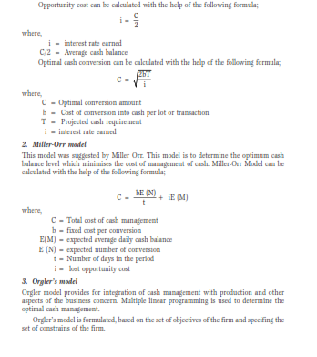

**15. EXPLAIN THE RECEIVABLE MANAGEMENT?**

The term receivable is defined as debt owed to the concern by customers arising from sale of goods or services in the ordinary course of business. Receivables are also one of the major parts of the current assets of the business concerns. It arises only due to credit sales to customers, hence, it is also known as Account Receivables or Bills Receivables.

Management of account receivable is defined as the process of making decision resulting to the investment of funds in these assets which will result in maximizing the overall return on the investment of the firm.

The objective of receivable management is to promote sales and profit until that point is

reached where the return on investment in further funding receivables is less than the cost of funds raised to finance that additional credit.

The costs associated with the extension of credit and accounts receivables are identified

as follows:

A. Collection Cost

B. Capital Cost

C. Administrative Cost

D. Default Cost.

**Collection Cost**

This cost incurred in collecting the receivables from the customers to whom credit sales

have been made.

**Capital Cost**

This is the cost on the use of additional capital to support credit sales which alternatively could have been employed elsewhere.

**Administrative Cost**

This is an additional administrative cost for maintaining account receivable in the form of salaries to the staff kept for maintaining accounting records relating to customers, cost of investigation etc.

**Default Cost**

Default costs are the over dues that cannot be recovered. Business concern may not be able to recover the over dues because of the inability of the customers.

**Factors Considering the Receivable Size**

Receivables size of the business concern depends upon various factors. Some of the important

factors are as follows:

***1. Sales Level***

Sales level is one of the important factors which determines the size of receivable of the firm. If the firm wants to increase the sales level, they have to liberalise their credit policy and terms and conditions. When the firms maintain more sales, there will be a possibility of large size of receivable.

***2. Credit Policy***

Credit policy is the determination of credit standards and analysis. It may vary from firm to firm or even some times product to product in the same industry. Liberal credit policy leads to increase the sales volume and also increases the size of receivable. Stringent credit policy reduces the size of the receivable.

***3. Credit Terms***

Credit terms specify the repayment terms required of credit receivables, depend upon the credit terms, size of the receivables may increase or decrease. Hence, credit term is one of the factors which affects the size of receivable.

***4. Credit Period***

It is the time for which trade credit is extended to customer in the case of credit sales.

Normally it is expressed in terms of ‘Net days’.

***5. Cash Discount***

Cash discount is the incentive to the customers to make early payment of the due date. A special discount will be provided to the customer for his payment before the due date.

***6. Management of Receivable***

It is also one of the factors which affects the size of receivable in the firm. When the management involves systematic approaches to the receivable, the firm can reduce the size of receivable.

**Exercise 4**



